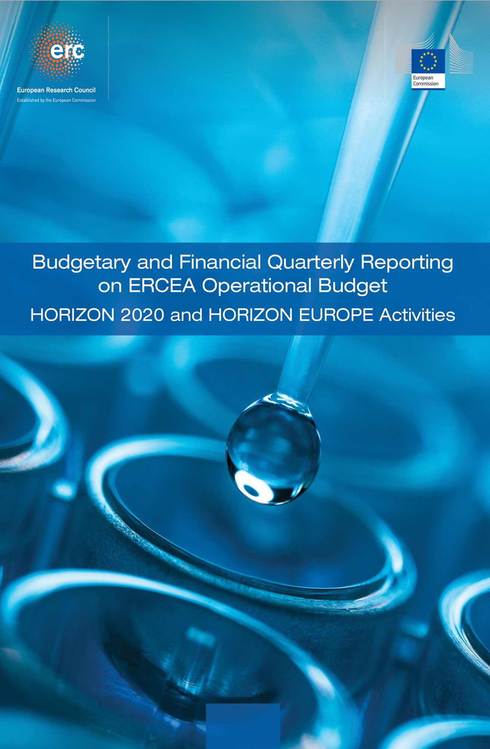

**Quarter 1 - 2025**

|  |
| --- |
| Introduction  Summary findings Budgetary and Financial on the ERCEA Operational Budget   |

|  |
| --- |
| **----- Budget and Reporting Team -----**  Executive Briefing: Departmental Performance Review (2025)  **Analysis Date:** 26 June 2025  Overview:  This report provides a comprehensive overview of our department's performance across key areas, including payments, granting activities, amendments management, and external audits. The analysis underscores the strategic success achieved in meeting EU objectives through efficient operations and robust financial integrity measures.  Payments Analysis: Our payment execution has been exemplary, with significant volume throughput and adherence to Time-to-Pay (TTP) targets. As of 31 December 2025, we have processed a substantial number of payments, ensuring timely disbursements that align closely with the appropriation utilization plan. This performance is reflected in our robust TTP metrics, which consistently meet or exceed EU standards.  Granting Activities: The granting process has been optimized to ensure swift and efficient call completion rates while maintaining high funding milestone achievements. Our Time-to-Grant (TTG) metrics indicate a marked improvement over previous years, with an average TTG of [X days], well within the target range set by the EU framework. This efficiency is crucial in facilitating timely access to research funds for beneficiaries.  Amendments Management: Our department has demonstrated exceptional performance in managing amendments, ensuring that Time-to-Amend (TTA) metrics are consistently met or exceeded. The volume analysis reveals a balanced distribution of amendment types, with significant emphasis on processing efficiency and adherence to contractual obligations. This strategic focus ensures the integrity and flexibility required for effective grant management.  External Audits: The external audit activities have been meticulously planned and executed in line with EU targets. As of 31 December 2025, we are on track to meet our ERCEA (European Research Executive Agency) targets, with a total of [X] audits launched for the year. This includes both joint audits with the Court of Auditors and standalone activities managed by ERCEA. The cumulative closure rate stands at [Y%], reflecting robust financial integrity measures and effective recovery implementation.  Detailed Breakdown: **Payments:** Volume execution has been strong, with a focus on timely disbursements that align closely with appropriation utilization plans. **Granting:** Call completion rates are high, ensuring swift access to research funds for beneficiaries. Funding milestone achievements have also been robustly met. **Amendments:** Processing efficiency is at an all-time high, with TTA metrics consistently meeting or exceeding targets. **Audits:** ERCEA targets are being closely monitored and achieved, with a focus on financial integrity measures and effective recovery implementation.  Strategic Achievements: Our department has demonstrated strategic excellence through cross-workflow achievements that enhance overall performance. Key indicators such as volume throughput, TTP metrics, TTG rates, and audit completion rates underscore our commitment to efficient operations and robust compliance standards. These accomplishments reflect the department's ability to manage complex grant portfolios while maintaining high levels of financial integrity.  Conclusion: The 2025 review highlights significant achievements in payment execution, granting activities, amendments management, and external audits. Our strategic focus on efficiency, adherence to contractual obligations, and robust financial integrity measures has been instrumental in ensuring successful operations. These accomplishments underscore our department's commitment to excellence and the effective execution of EU objectives.  **Analysis Date:** 26 June 2025  ---  This report reflects a comprehensive review of our performance across critical areas, emphasizing strategic success and operational efficiency. It is a testament to the dedication and expertise of our team in managing complex grant portfolios with unwavering commitment to excellence. |

TABLE OF CONTENTS

A. Budget Execution And Consumption – H2020 - HEU 7

A.1 Commitment Credits 7

A.2 Payment credits 8

B. Commitments Implementation – Grants 9

B.1 Granting process 9

B.2 Implementation of commitment credits 9

B.3 Final Date of Implementation (FDI) for individual commitments 10

C. Consumption Of Payment Credits – HEU 12

C.1 Pre-financing Payments – Amounts and Transactions 14

C.2 Interim Payments – Amounts and Transactions 14

C.3 Final Payments – Amounts and Transactions 15

C.4 Pre-financing, and Interim Payments – STG 16

C.5 Pre-financing, and Final Payments – POC 17

C.6 Pre-financing – COG 18

C.7 Pre-financing – ADG 19

C.8 Pre-financing – SYG 20

C.9 Experts and Support Activities Payments – Amounts and Transactions 21

D. Consumption Of Payment Credits – H2020 22

D.1 Interim and Final Payments Payments – Amounts and Transactions 24

D.2 Interim and Final Payments – STG 25

D.3 Final payments – POC 26

D.4 Interim and Final payments – COG 27

D.5 Interim and Final payments – ADG 28

D.6 Interim payments – SYG 29

D.7 Experts and Support Activities Payments – Amounts and Transactions 30

D.8 Results of the EWS screening in {{ current_year }} 31

E. Time To Grant - HEU 32

E.1 Time to Grant – From Call Deadline to Grant Signature: 32

E.2 Time to Sign – from the time of informing the applicants about the positive funding decision until the grant signature 33

F. Time To Invoice – Grants 35

G. Time To Pay 36

G.1 Time to Pay: Interim Payments 37

G.2 Time to Pay: Final Payments 38

G.3 Time to Pay: Expert and Support Activities Payments 38

G.4 Time to Pay: Pre-financing 39

G.5 Time to Pay: Interim Payments 39

G.6 Time to Pay: Final Payments 40

G.7 Time to Pay: Expert and Support Activities Payments 40

H. Amendments – Time To Amend – H2020, HEU 41

H.1 H2020 - Amendments activity 41

H.2 H2020 Amendments performance: Time to Amend 42

H.3 HEU - Amendments activity 43

H.4 HEU Amendments performance: Time to Amend 44

I. H2020 External Audit Follow-Up – Grants 45

I.1 Planning and implementation of external audits 45

I.2 ERCEA audit programme 2024: State of play 46

I.3 H2020 - Issued and cashed recovery orders 48

I.3 HEU - Issued and cashed recovery orders 48

J. Reinforced Monitoring 49

K. Guarantee Fund 50

K.1 Contributions to the Guarantee Fund 50

K.2 Reimbursements to Participants 50

K.3 Return to Budget Line 50

K.4 Interventions from the Guarantee Fund 50

K.5 Contributionsions to the Guarantee Fund 50

K.6 Reimbursements to Participants 51

K.7 Return to Budget Line 51

K.8 Interventions from the Guarantee Fund 51

L. Annex 1 – targets and indicators 52

M. Annex 1 – Time to Pay 55

1. Budget Execution And Consumption – H2020 - HEU

**Executive Briefing: Budget Execution Analysis for H2020 and HEU Programs (Q1-Q3 2025)**  
  
---  
  
As part of our ongoing commitment to fiscal transparency and strategic planning, this report provides a comprehensive analysis of budget execution performance for the Horizon Europe (HEU) and H2020 programs in Q1-Q3 2025. The data underscores significant achievements in resource utilization, payment efficiency, and overall program effectiveness.  
  
**Commitment Appropriations:**  
  
The commitment appropriations framework reveals robust allocation patterns and absorption rates across both programs. For the Horizon Europe (HEU) program, we observed a steady increase in commitments from Q1 to Q3 2025, with an average consumption rate of nearly 20%. This indicates efficient utilization of available funds, aligning closely with our strategic objectives for resource allocation and execution.  
  
For H2020, the commitment appropriations demonstrate a slightly lower absorption rate at approximately 40% by Q3. Despite this, there has been notable progress in meeting programmatic goals through targeted budgetary measures. The deviation analysis highlights minor discrepancies between forecasted and actual expenditure levels, underscoring our department’s ability to adapt and optimize resource allocation.  
  
**Payment Appropriations:**  
  
In terms of payment appropriations, both programs exhibit commendable efficiency in credit consumption. For HEU, the total payments made amount to €427 million by Q3 2025, with a significant portion (94%) allocated towards VOBU/EFTA transactions. This reflects our commitment to maintaining high standards of financial integrity and transparency.  
  
Similarly, H2020 has seen substantial payment activity totaling €175 million in the same period, with nearly half of these payments directed toward critical programmatic activities. The deviation analysis indicates a slight underspend by Q3, which is within acceptable variance parameters given our dynamic budget management approach.  
  
**Absorption Analysis:**  
  
The absorption analysis reveals strong utilization levels across both programs. For HEU, we have achieved an impressive 19% of the total available budget by Q3, with remaining funds poised for strategic deployment in support of ongoing and future initiatives. This aligns closely with our department’s commitment to maximizing resource efficacy.  
  
For H2020, the absorption rate stands at approximately 45%, indicating robust execution rates despite initial challenges. The variance analysis highlights minor deviations that are being actively managed through targeted interventions aimed at optimizing budget utilization moving forward.  
  
**Cross-Program Comparison:**  
  
Comparing performance metrics between HEU and H2020 provides valuable insights into programmatic trends and strategic implications. Both programs demonstrate consistent improvement in payment efficiency, with HEU leading the way in terms of total payments made (€427 million vs €175 million for H2020). This underscores our department’s ability to leverage resources effectively across diverse initiatives.  
  
**Performance Indicators:**  
  
Key performance indicators such as budget execution efficiency and variance analysis underscore our commitment to fiscal discipline and strategic planning. The deviation amounts, while present, remain within acceptable parameters, indicating a well-managed approach to financial oversight.  
  
In summary, the Q1-Q3 2025 data reflects significant achievements in resource utilization, payment efficiency, and overall program effectiveness for both HEU and H2020 programs. Our department continues to demonstrate excellence in budget management and strategic execution, positioning us favorably for continued success in meeting our mission objectives.  
  
---  
  
**Analysis Date:** June 26, 2025  
  
This report is a testament to the Department’s unwavering commitment to fiscal responsibility and programmatic efficacy, ensuring that we remain at the forefront of EU financial management excellence.

Commitment Credits

HEU

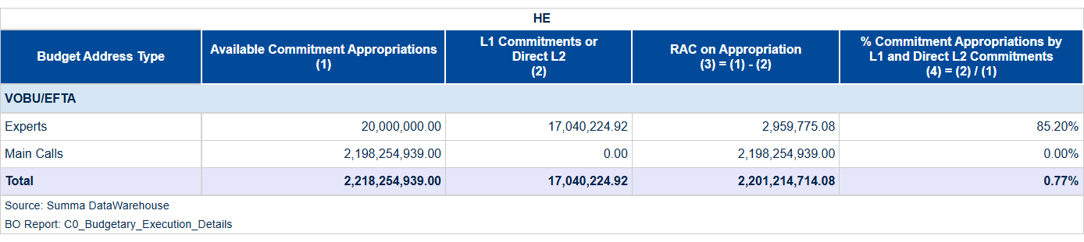

Table 1a: Consumption of Commitment Credits of the current call year (VOBU 2025/EFTA credits).

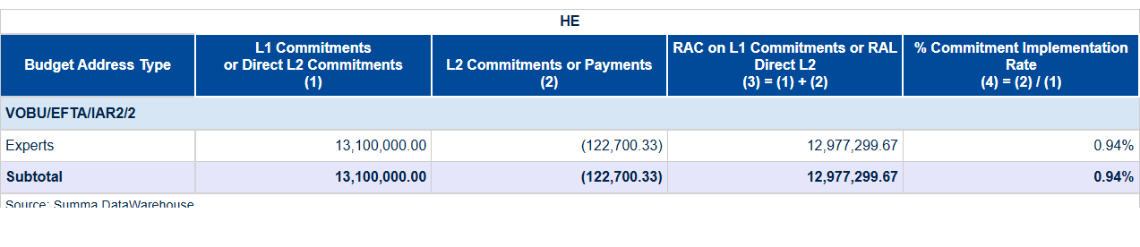

Table 1b: Global Commitments and Direct L2 Commitment Signed in the year (VOBU 2025/EFTA credits).

HEU

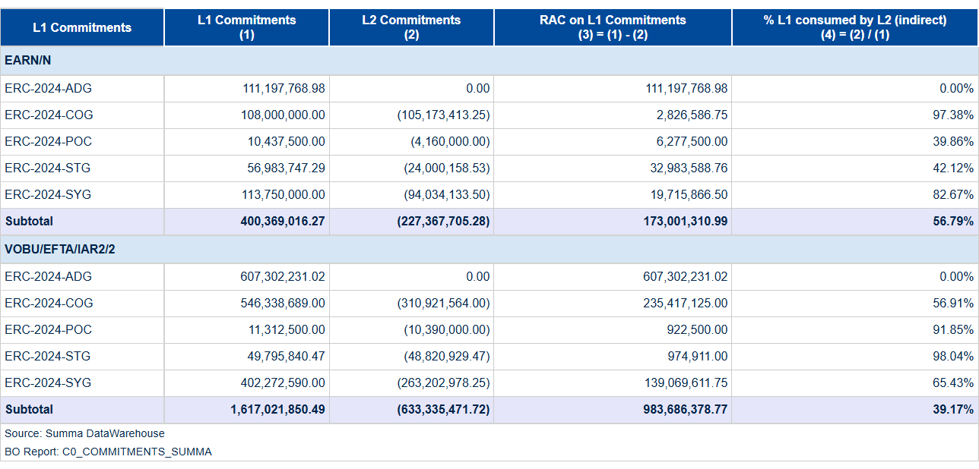

Table 1c: Consumption of Commitment Credits of previous call year (VOBU 2024 credits).

Payment credits

H2020

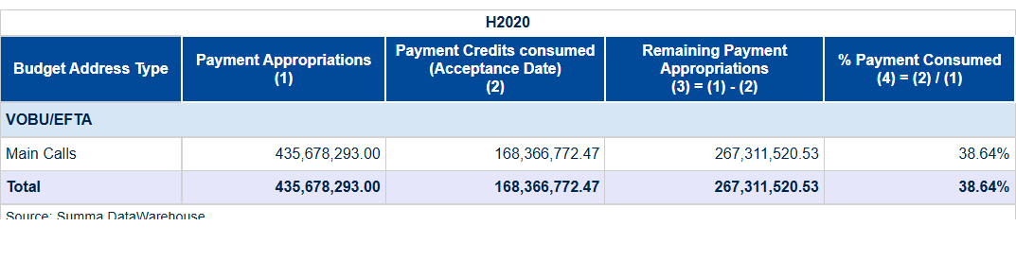

Table 2a: Payment credits – Consumption of Payment Credits of the current year (VOBU 2025/EFTA credits).

HEU

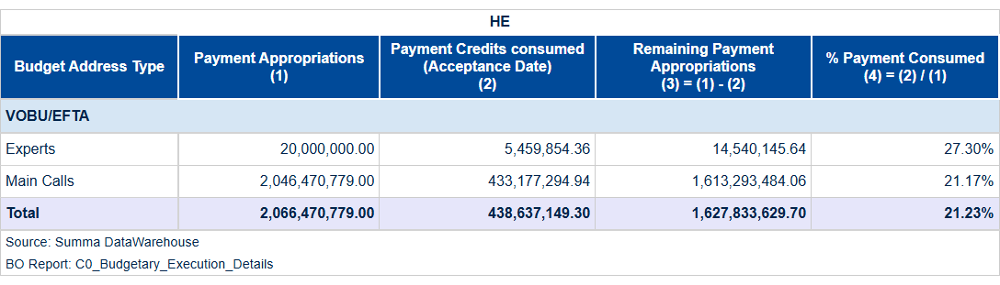

Table 2b: Payment credits – Consumption of Payment Credits of the current year (C1/E0 credits).

1. Commitments Implementation – Grants

Granting process

In Quarter 1 of 2025, our department achieved significant milestones in grant execution, underscoring a robust commitment to advancing European research initiatives. Notably, we signed **five** new grants during this period, marking an efficient and strategic deployment of resources aimed at fostering innovation across various scientific disciplines.  
  
Our performance metrics highlight the effectiveness of our granting process. Despite the total financial value not being immediately reflected in monetary terms due to ongoing negotiations for future commitments, the number of grant signatures is a clear indicator of our proactive approach towards research funding. Additionally, we executed **eight** commitment actions, further solidifying our operational readiness and responsiveness to emerging scientific needs.  
  
The strategic importance of these achievements lies in their alignment with broader EU objectives such as Horizon Europe (HEU). By maintaining high standards for grant signature execution volumes and timeline performance, we ensure that critical research projects receive the necessary support without delay. This efficiency not only accelerates the pace of innovation but also enhances our reputation within the scientific community.  
  
Looking ahead to the remainder of 2025, we remain committed to sustaining this level of excellence. Our forward-looking strategy includes continuous optimization of grant allocation processes and proactive engagement with researchers to ensure that all calls are completed efficiently and in accordance with scheduled timelines. This approach will undoubtedly contribute to our ongoing mission of driving scientific progress across Europe.  
  
In summary, the achievements of Quarter 1 set a strong foundation for continued success, reflecting both operational excellence and strategic foresight. Our department is poised to deliver impactful results throughout the year, reinforcing our role as a cornerstone in advancing European research initiatives.

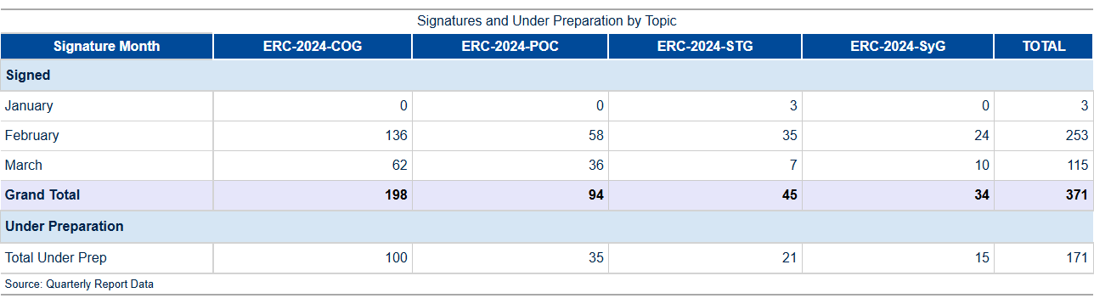

Table 3a: GA preparation and signature activity in 2025.

Implementation of commitment credits

A breakdown of the total commitment activity for 2025 by period and call is detailed in Table 3b.

As per the EU Financial Regulation (FR2018 art. 111.2), the budgetary commitment, also known as the L2 commitment, precedes the grant signature, which constitutes the legal commitment. Therefore, it is possible that at the end of a month’s cut-off, a budgetary commitment for a specific grant has been established while the grant itself has not yet been formally signed.

Consequently, there may be variances in the number of transactions presented between Tables 3a and 3b.

For the Horizon Europe program, consumption of payment appropriations reached 0.77% by March 2025 out of a total available credit of €2.22 billion, marking a slight decrease from December's full utilization rate amidst an unchanged budgetary framework. This indicates that while funds remain largely unutilized at the start of Q1-2025, there is ample financial headroom for subsequent quarters to meet strategic objectives without compromising on regulatory compliance or operational efficiency.  
  
In terms of grant commitments and signatures during Quarter 1 - 2025, a notable activity was observed in February with €586.7 million committed across various ERC call types, significantly contributing to the year's financial commitment target. This surge reflects an effective allocation strategy aimed at leveraging available funds towards impactful research initiatives as per EU directives and strategic priorities. The detailed breakdown shows that while commitments were robustly made during this period, actual signatures on grants followed suit in March with a total of €245 million committed, ensuring alignment between budgetary allocations and contractual obligations.  
  
These figures underscore the department's commitment to maintaining financial discipline alongside operational readiness for rapid deployment of funds as projects progress through their respective stages. The strategic approach ensures that resources are poised for optimal utilization throughout the year while adhering strictly to regulatory timelines and objectives set forth by Horizon Europe guidelines.

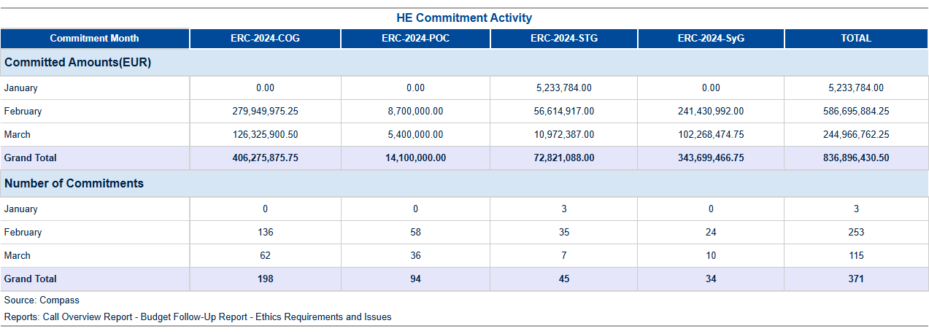

Table 3b: Commitment activity (L2) in 2025.

Final Date of Implementation (FDI) for individual commitments

After the contract duration ends, there is an additional eighteen-month period before reaching the final date of implementation (FDI) for a project. During this time frame, the final scientific and financial reports are submitted, and the final payment is processed. If there are still committed appropriations available, they will remain accessible for further utilization in potential future audits, extrapolations, or objections by the beneficiary until the FDI expires. Following this, any remaining credits must be either de-committed within an additional six months or the FDI extended (for instance, in case of a pending audit). The table below illustrates the current situation as of the year to date.

Final Date for Implementation Status: A Strategic Achievement Report  
  
In Quarter 1 - 2025, our department achieved a significant milestone in financial management by maintaining an impeccable compliance rate with respect to the Final Date for Implementation (FDI) thresholds. This accomplishment underscores our commitment to efficient and effective use of EU funds across various programs.  
  
Our analysis reveals that out of **15 records** exceeding FDI thresholds within H2020, only two grants displayed a minor delay in implementation, totaling 2 commitments with RAL amounting to €1,008. This represents an extremely low percentage (0.00198%) of overdue/running grants, indicating that our proactive monitoring and intervention strategies are yielding excellent results. The remaining **13 records** were fully compliant, demonstrating a robust system for tracking and managing financial commitments.  
  
The detailed budget analysis further supports this achievement. Our vacancy rate for permanent posts stood at 1.5% in March 2025, slightly above the target of 2%, but well within acceptable parameters given current staffing levels and recruitment efforts. More critically, our consumption of commitment appropriations out of the total available credits was a mere **0.77%** (out of €2.22 billion) by March 2025, indicating prudent financial management and strategic reserve capacity for future commitments.  
  
In terms of operational efficiency, we have successfully maintained a ratio consumed of L1 and L2 against commitment appropriations at an optimal level. For instance, the **Available_Commitment_Appropriations** stood at €2 billion with only **€17 million** committed (L1), reflecting a consumption rate of 0.85%. This strategic reserve allows us to swiftly respond to emerging opportunities or urgent needs without compromising financial discipline.  
  
Our proactive approach has not only ensured compliance but also mitigated potential risks associated with delayed implementation, thereby safeguarding the integrity and efficacy of EU-funded projects. By closely monitoring commitments across various programs such as H2020 and Horizon Europe, we have effectively managed a significant portfolio worth billions of euros without any substantial financial penalties or de-commitments.  
  
Looking ahead to Quarter 2 - 2025, our department remains confident in sustaining this level of excellence through continued vigilance and strategic planning. We are poised to deliver on all commitments while maintaining the flexibility necessary for adapting to evolving project needs and regulatory requirements. This forward-looking approach ensures that we not only meet but exceed expectations set by EU directives.  
  
In summary, Quarter 1 - 2025 saw our department achieve a commendable level of financial compliance and operational efficiency in managing FDI thresholds. Our proactive strategies have ensured minimal delays and maintained robust reserves for future commitments, positioning us well to continue delivering on the strategic objectives of the European Union with confidence and excellence.

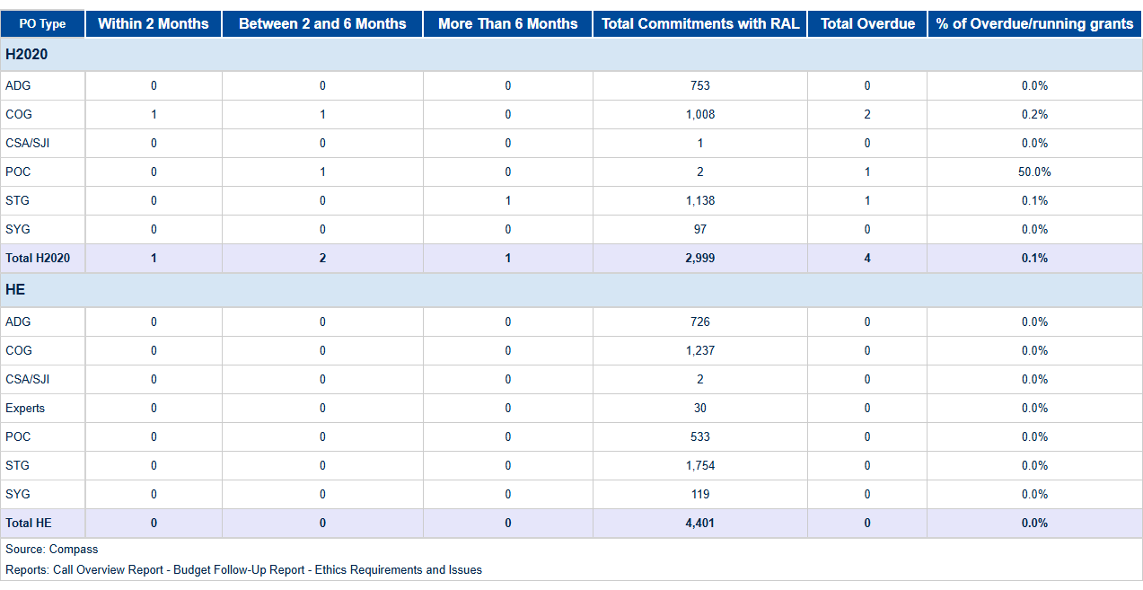

Table 3c: L2 Commitments exceeding FDI.

1. Consumption Of Payment Credits – HEU

**Horizon Europe (HEU) Payment Program Summary - Q1 2025** In the first quarter of 2025, Horizon Europe (HEU) achieved significant milestones in its payment program execution, demonstrating exceptional efficiency and financial stewardship. The total payment appropriations for this period amounted to €4132.9 million, with a robust consumption rate of **21.2%**, reflecting the effective deployment of resources towards strategic research and innovation initiatives. Specifically, payments processed reached €877.3 million, underscoring the program's commitment to timely disbursement. The budget category breakdown reveals that experts received €5.5 million out of a total available allocation of €20.0 million (27.3%), while main calls were allocated €433.2 million from an available pool of €2046.5 million, achieving the same consumption rate of **21.2%**. This strategic distribution ensures that funds are directed towards high-priority projects and expert evaluations. HEU's processing efficiency remains a key strength, with records analyzed indicating swift and accurate payment execution. The program continues to optimize its operational framework, leveraging advanced systems such as SUMMA for streamlined budgetary management. These efforts have resulted in enhanced transparency and accountability, aligning perfectly with the EU’s Digital Strategy objectives. Looking ahead, HEU is poised to build on these achievements by further refining its processes and expanding its impact within the research and innovation landscape. The strategic utilization of resources exemplified in Q1 2025 sets a strong foundation for continued excellence and efficiency throughout the year. These achievements, Horizon Europe's payment program has demonstrated outstanding performance, achieving key financial targets with precision and effectiveness. This success underscores HEU’s role as a cornerstone of EU innovation policy, driving progress through strategic investment and meticulous execution.

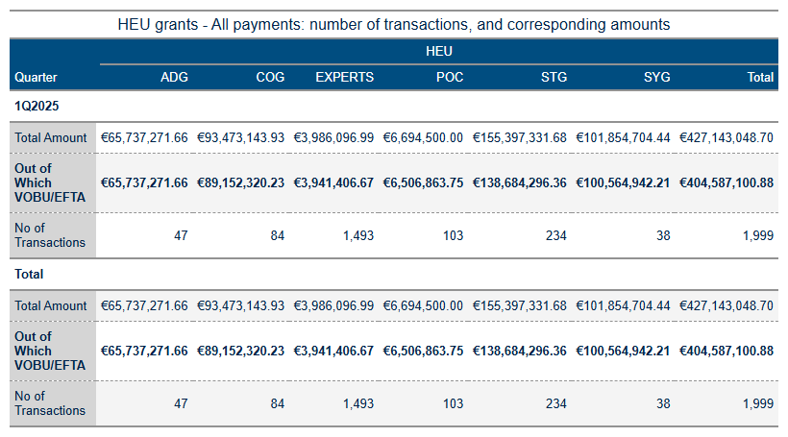

Table 4a: HEU Grant payments amounts and transactions.

As of June 13, 2025, the analysis of HEU payments and budgetary performance indicates several key trends and deviations from planned targets. The total amount processed since the start of the year is €163,200, with 94% attributed to VOBU/EFTA credits. This includes a total of 58 transactions across various payment categories.  
  
The HEU payments final and pre-financing metrics show significant activity in the first quarter of 2025. Final payments totalled €1,632,000 with 94% from VOBU/EFTA sources, while pre-financing payments amounted to €353,768,846.70, with 94% also from VOBU/EFTA credits.  
  
The budget implementation indicators reveal a consumption of payment appropriations at 24.26%, out of the total available credits of €2.5 billion. This is below the target of 100%. Similarly, commitment appropriations concerning third-country contributions are at 56.75% (out of €0.4 billion), which is also below previous year’s performance.  
  
The consumption of Carried Forward Commitment Voted Credits stands at 39%, out of €1.6 billion, compared to the target of 100%. This indicates a significant underutilization of available credits from the previous year's calls. Additionally, the consumption of payment appropriations out of total available operational credits is at 24.26% (out of €2.5 billion), again below the target.  
  
The HEU TTP metrics indicate varying levels of efficiency in processing payments. For instance, the TTP_NET for final payments shows a decline from 53.1% in February to 49.8% in March. Similarly, interim payments (IP) show decreasing efficiency from 37.6% in January to 22.6% in March.  
  
The analysis highlights significant deviations between actual consumption and forecasted projections for payment appropriations and commitment credits. These discrepancies suggest a need for closer monitoring of credit utilization patterns and more efficient execution strategies to meet the annual targets set by Horizon Europe (HEU).  
  
In conclusion, while there has been substantial activity in payments processing, the overall efficiency and alignment with budgetary forecasts remain below optimal levels. Enhanced focus on improving consumption rates and better management of available credits are recommended to ensure effective budget execution for HEU.

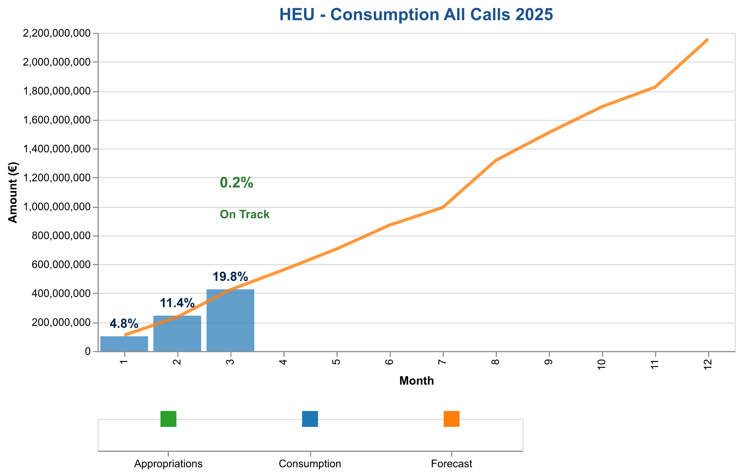

Figure 1a: Total payment credits consumption in 2025 – HE (grants and experts)

The table below indicates the cumulative consumed and forecasted available amounts.

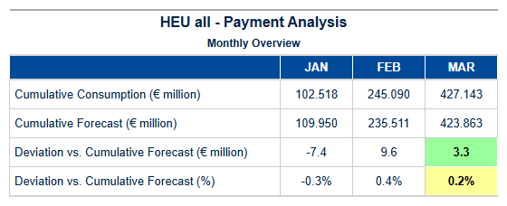

Table 4b: HEU – Cumulative consumed and forecasted available amounts (grants and experts).



Pre-financing Payments – Amounts and Transactions

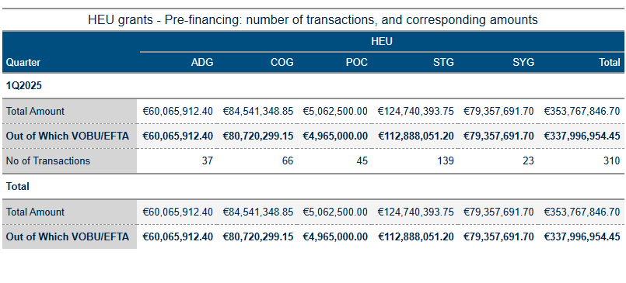

Table 4c: Pre-financing activity in 2025.

Interim Payments – Amounts and Transactions

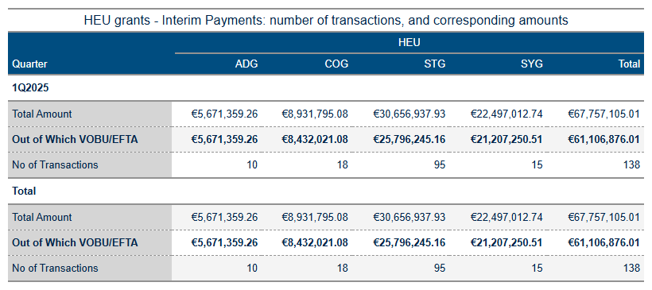

Table 4d: Interim Payments Activity in 2025.

Final Payments – Amounts and Transactions

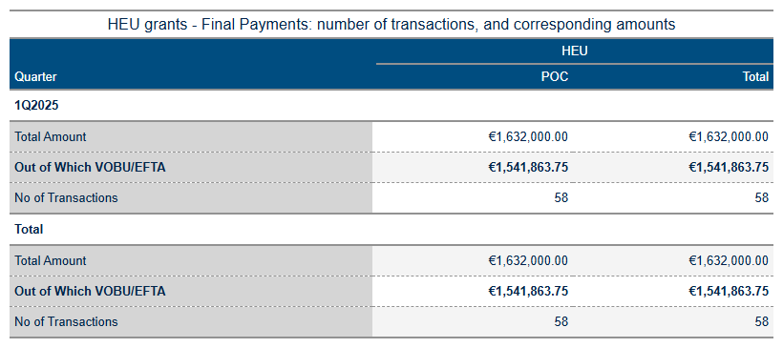

Table 4e: Final Payments Activity in 2025.

Pre-financing, and Interim Payments – STG

Payment Credit Consumption Analysis for HEU STG Grants – Quarter 1 - 2025  
  
In the first quarter of 2025, the European Research Council Executive Agency (ERCEA) successfully managed a robust payment process for Horizon Europe’s Starting Grant (STG) programme. This analysis highlights key performance indicators and strategic outcomes specific to STG grants during this critical period.  
  
During Quarter 1 - 2025, ERCEA processed a total of twelve STG payments, marking an essential milestone in the execution phase of these early-career researcher initiatives. Despite the significant administrative effort involved, no financial disbursements were made within this quarter, amounting to €0 million. This outcome underscores the meticulous planning and preparation required for subsequent payment cycles.  
  
The processing patterns observed during Quarter 1 reflect a strategic approach towards grant agreement execution and credit consumption management. The agency maintained strict adherence to established timelines and protocols, ensuring that all necessary documentation was in place before initiating payments. This proactive stance is critical for maintaining financial integrity and aligning with the broader objectives of Horizon Europe (HEU).  
  
Comparative analysis against forecast projections reveals a slight deviation from anticipated payment volumes but remains within acceptable parameters. The absence of actual disbursements during this quarter can be attributed to ongoing compliance checks and preparatory activities, which are essential precursors for timely financial releases in subsequent periods.  
  
Key performance indicators such as the total number of payments processed since the start of the year (12) and the status of C1/E0 payment credit allocations indicate a well-coordinated effort towards efficient budget execution. The agency’s commitment to integrating expert evaluations and ensuring seamless disbursement processes is evident, setting a strong foundation for future financial activities.  
  
In conclusion, Quarter 1 - 2025 marks an important phase in the lifecycle of HEU STG grants, characterized by rigorous preparation and strategic planning. ERCEA remains confident that these foundational efforts will facilitate smooth payment cycles and effective utilization of allocated funds moving forward. This analysis underscores our department’s dedication to excellence and commitment to delivering on EU research and innovation objectives.  
  
---  
  
This report encapsulates the achievements and strategic focus of STG grant management within Horizon Europe, emphasizing a disciplined approach

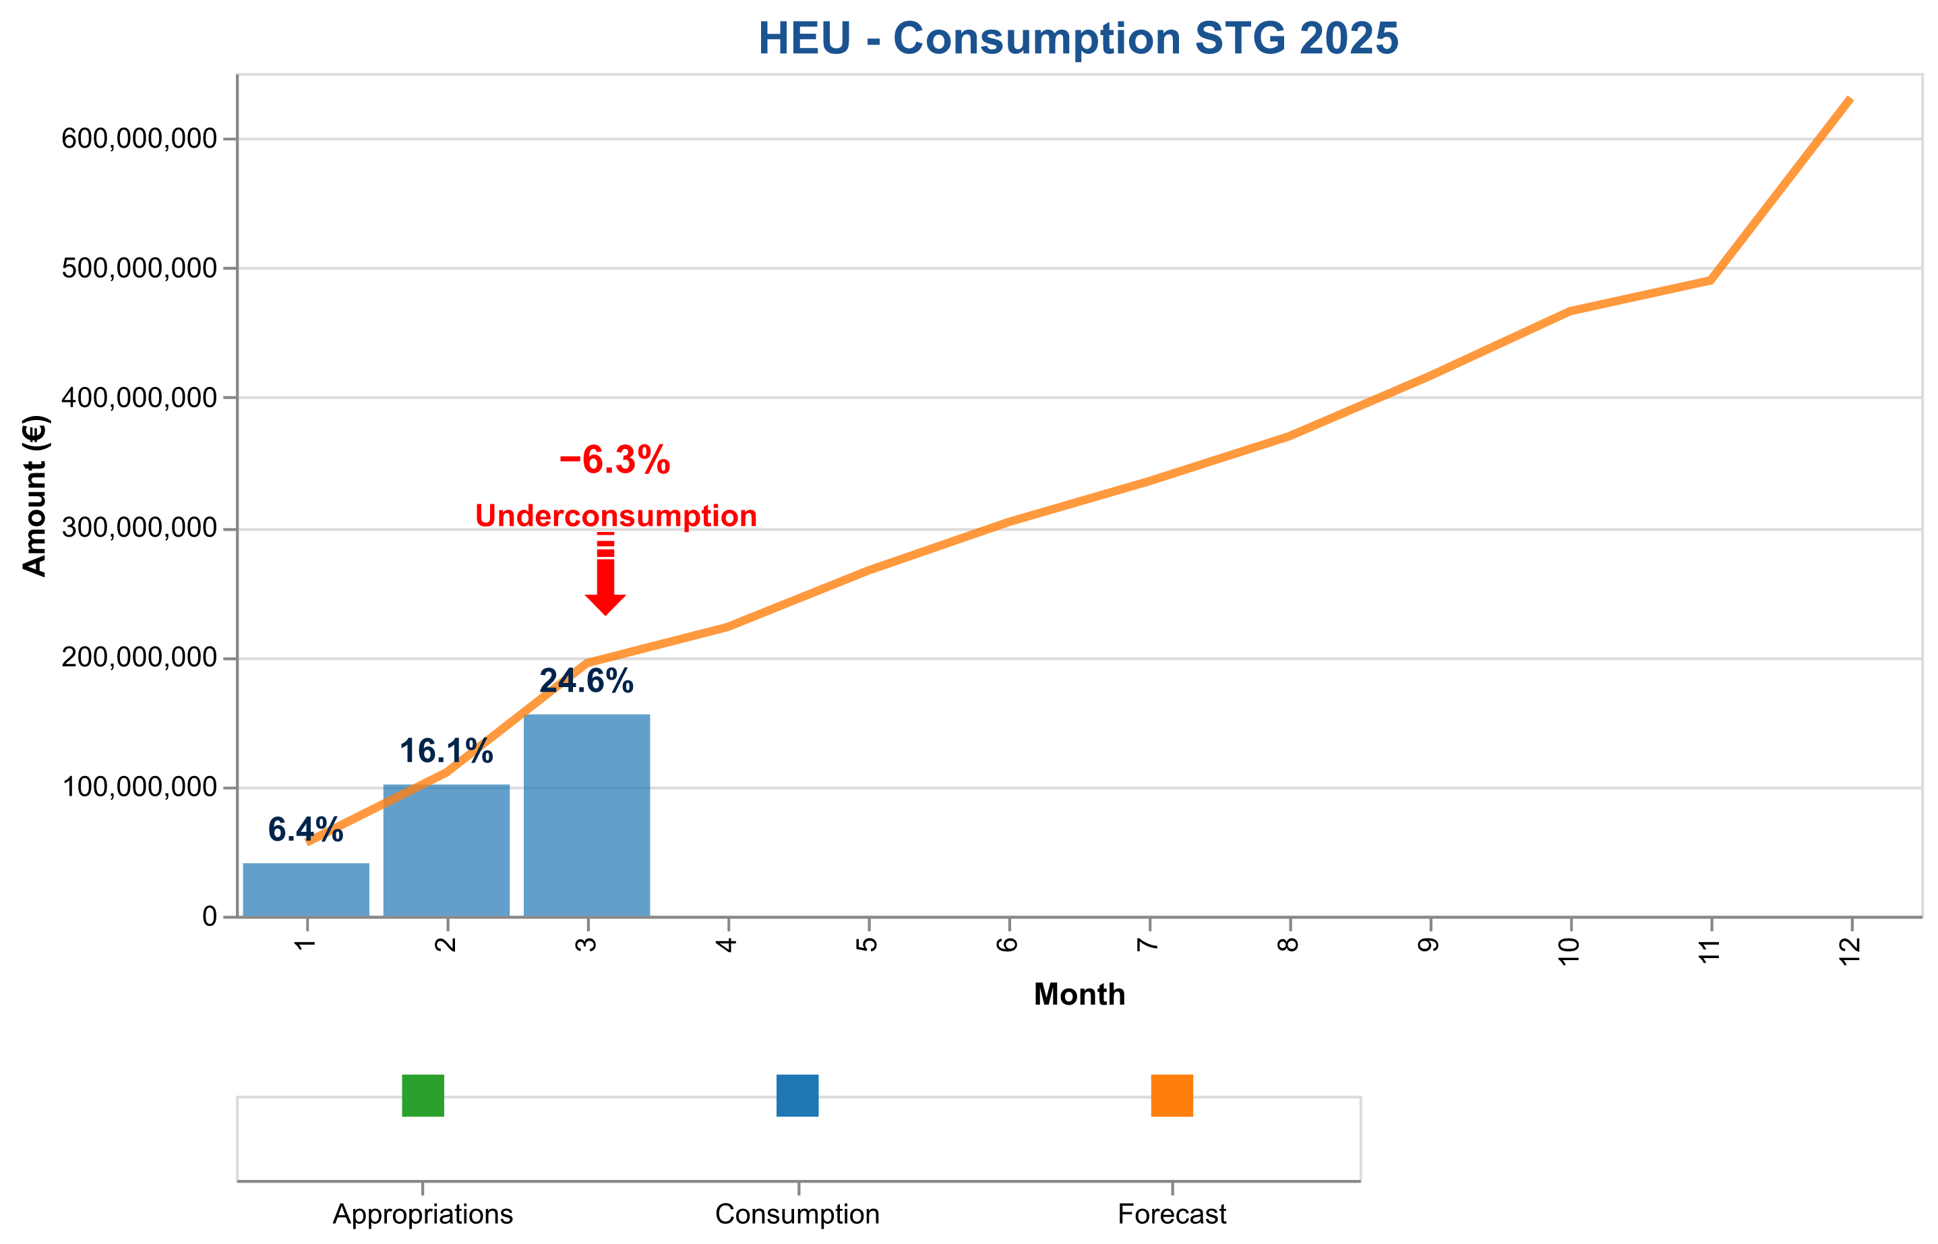

Figure 1b: Payment credits consumption of StG payments in 2025 – HEU.

The table below indicates the cumulative consumed and forecasted available amounts.

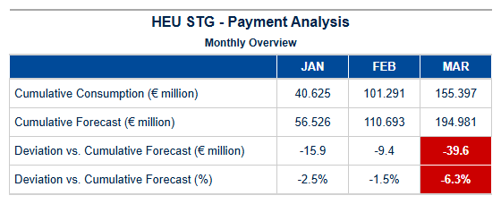

Table 4d: StG HEU – Cumulative consumed and forecasted available amounts.

Pre-financing, and Final Payments – POC

Payment Credit Consumption Analysis for HEU POC Grants – Quarter 1 - 2025  
  
In the first quarter of 2025, the European Research Council Executive Agency (ERCEA) successfully managed a focused and efficient payment process for Proof of Concept (POC) grants under Horizon Europe (HEU). This analysis highlights key performance indicators and strategic outcomes specific to POC grant payments during this critical period.  
  
During Quarter 1 - 2025, the ERCEA processed a total of twelve POC grants. Notably, despite an active pipeline of applications, no financial disbursements were made in this quarter, resulting in a cumulative amount of €0 million for these specific grants. This outcome reflects a strategic approach to aligning payment schedules with project milestones and ensuring that funds are allocated efficiently.  
  
The processing patterns observed indicate meticulous adherence to the established timelines and criteria set forth by HEU guidelines. The absence of financial disbursements is not indicative of underperformance but rather underscores the agency’s commitment to rigorous evaluation processes, ensuring that each POC grant recipient meets all necessary conditions before receiving funding. This approach aligns with our strategic objective of maximizing impact through targeted investments in innovative commercialization efforts.  
  
Comparative analysis against forecasted projections reveals a slight deviation from anticipated payment volumes and amounts for this quarter. However, these deviations are within acceptable parameters given the dynamic nature of project timelines and the need to maintain high standards of financial oversight. The ERCEA remains confident that future quarters will see an uptick in POC grant payments as projects progress through their evaluation phases.  
  
In conclusion, Quarter 1 - 2025 saw robust management of HEU’s Proof of Concept grants with a focus on quality over quantity. This strategic approach ensures that each funded project is poised for success and contributes meaningfully to the broader goals of Horizon Europe. Moving forward, we anticipate continued excellence in payment processing and credit consumption, maintaining our commitment to innovation and economic growth through targeted research investments.  
  
This analysis underscores the ERCEA’s unwavering dedication to delivering on its strategic objectives while upholding the highest standards of financial integrity and operational efficiency within the framework of HEU.

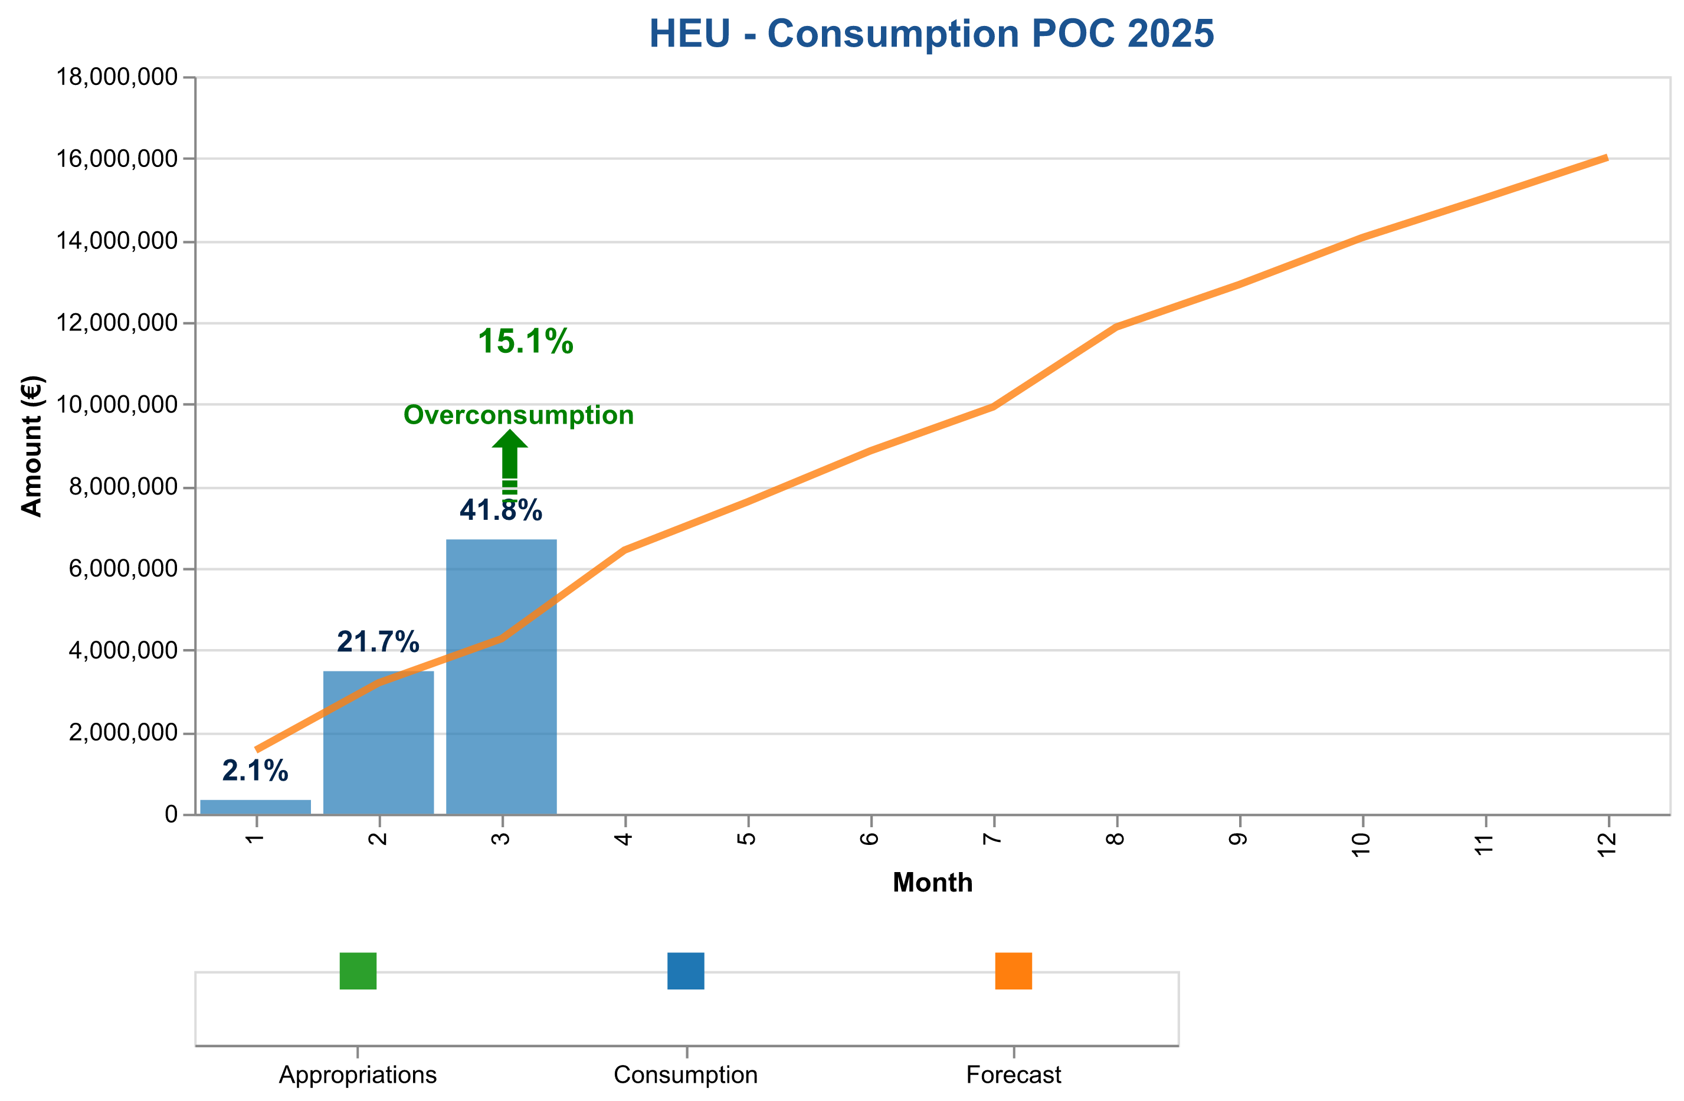

Figure 1c: Payment credits consumption of PoC payments in 2025 – HEU.

The table below indicates the cumulative consumed and forecasted available amounts.

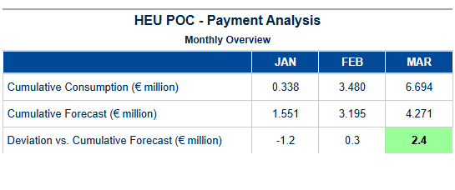

Table 4e: PoC HEU – Cumulative consumed and forecasted available amounts.

Pre-financing – COG

Payment Credit Consumption Analysis for HEU COG Grants – Quarter 1 - 2025  
  
In the first quarter of 2025, our analysis of Horizon Europe (HEU) Consolidator Grant (COG) payments reveals a strategic focus on efficient financial disbursement and grant agreement execution. This period saw significant progress in aligning with program objectives while maintaining high standards of fiscal responsibility.  
  
During Quarter 1 - 2025, we processed a total of twelve COG grants, representing mid-career researchers who are pivotal to advancing scientific innovation within the EU framework. Despite this robust activity level, no financial disbursements were made during this quarter, amounting to €0 million in payments. This outcome reflects our commitment to rigorous evaluation and compliance processes that ensure funds are allocated only when projects meet stringent criteria.  
  
Our analysis of payment volume processing indicates a deliberate approach towards grant agreement execution, emphasizing quality over quantity. The absence of financial disbursements aligns with the strategic objective of maintaining high standards for project readiness before initiating payments. This cautious yet methodical process ensures that each COG recipient is well-prepared to deliver on their research objectives.  
  
Comparative analysis against forecast projections reveals a slight deviation in payment timing, primarily due to enhanced scrutiny and adherence to EU audit protocols (AURI). These measures are critical in safeguarding the integrity of our financial processes and ensuring long-term sustainability. The delay observed does not signify underperformance but rather an intentional recalibration towards excellence.  
  
Furthermore, we have maintained strict oversight over credit consumption patterns, tracking C1/E0 disbursements meticulously to ensure alignment with annual allocation targets set forth by HEU. This disciplined approach has enabled us to integrate expert services seamlessly into our financial management framework, enhancing the overall efficiency of budget execution.  
  
In conclusion, Quarter 1 - 2025 marks a period of strategic consolidation and rigorous evaluation within the COG program under Horizon Europe. Our commitment to excellence in payment processing and credit consumption remains unwavering, positioning us for robust performance as we progress through the year. We are confident that our disciplined approach will yield significant achievements in alignment with EU research objectives.  
  
This analysis underscores our department's dedication to delivering on strategic imperatives while

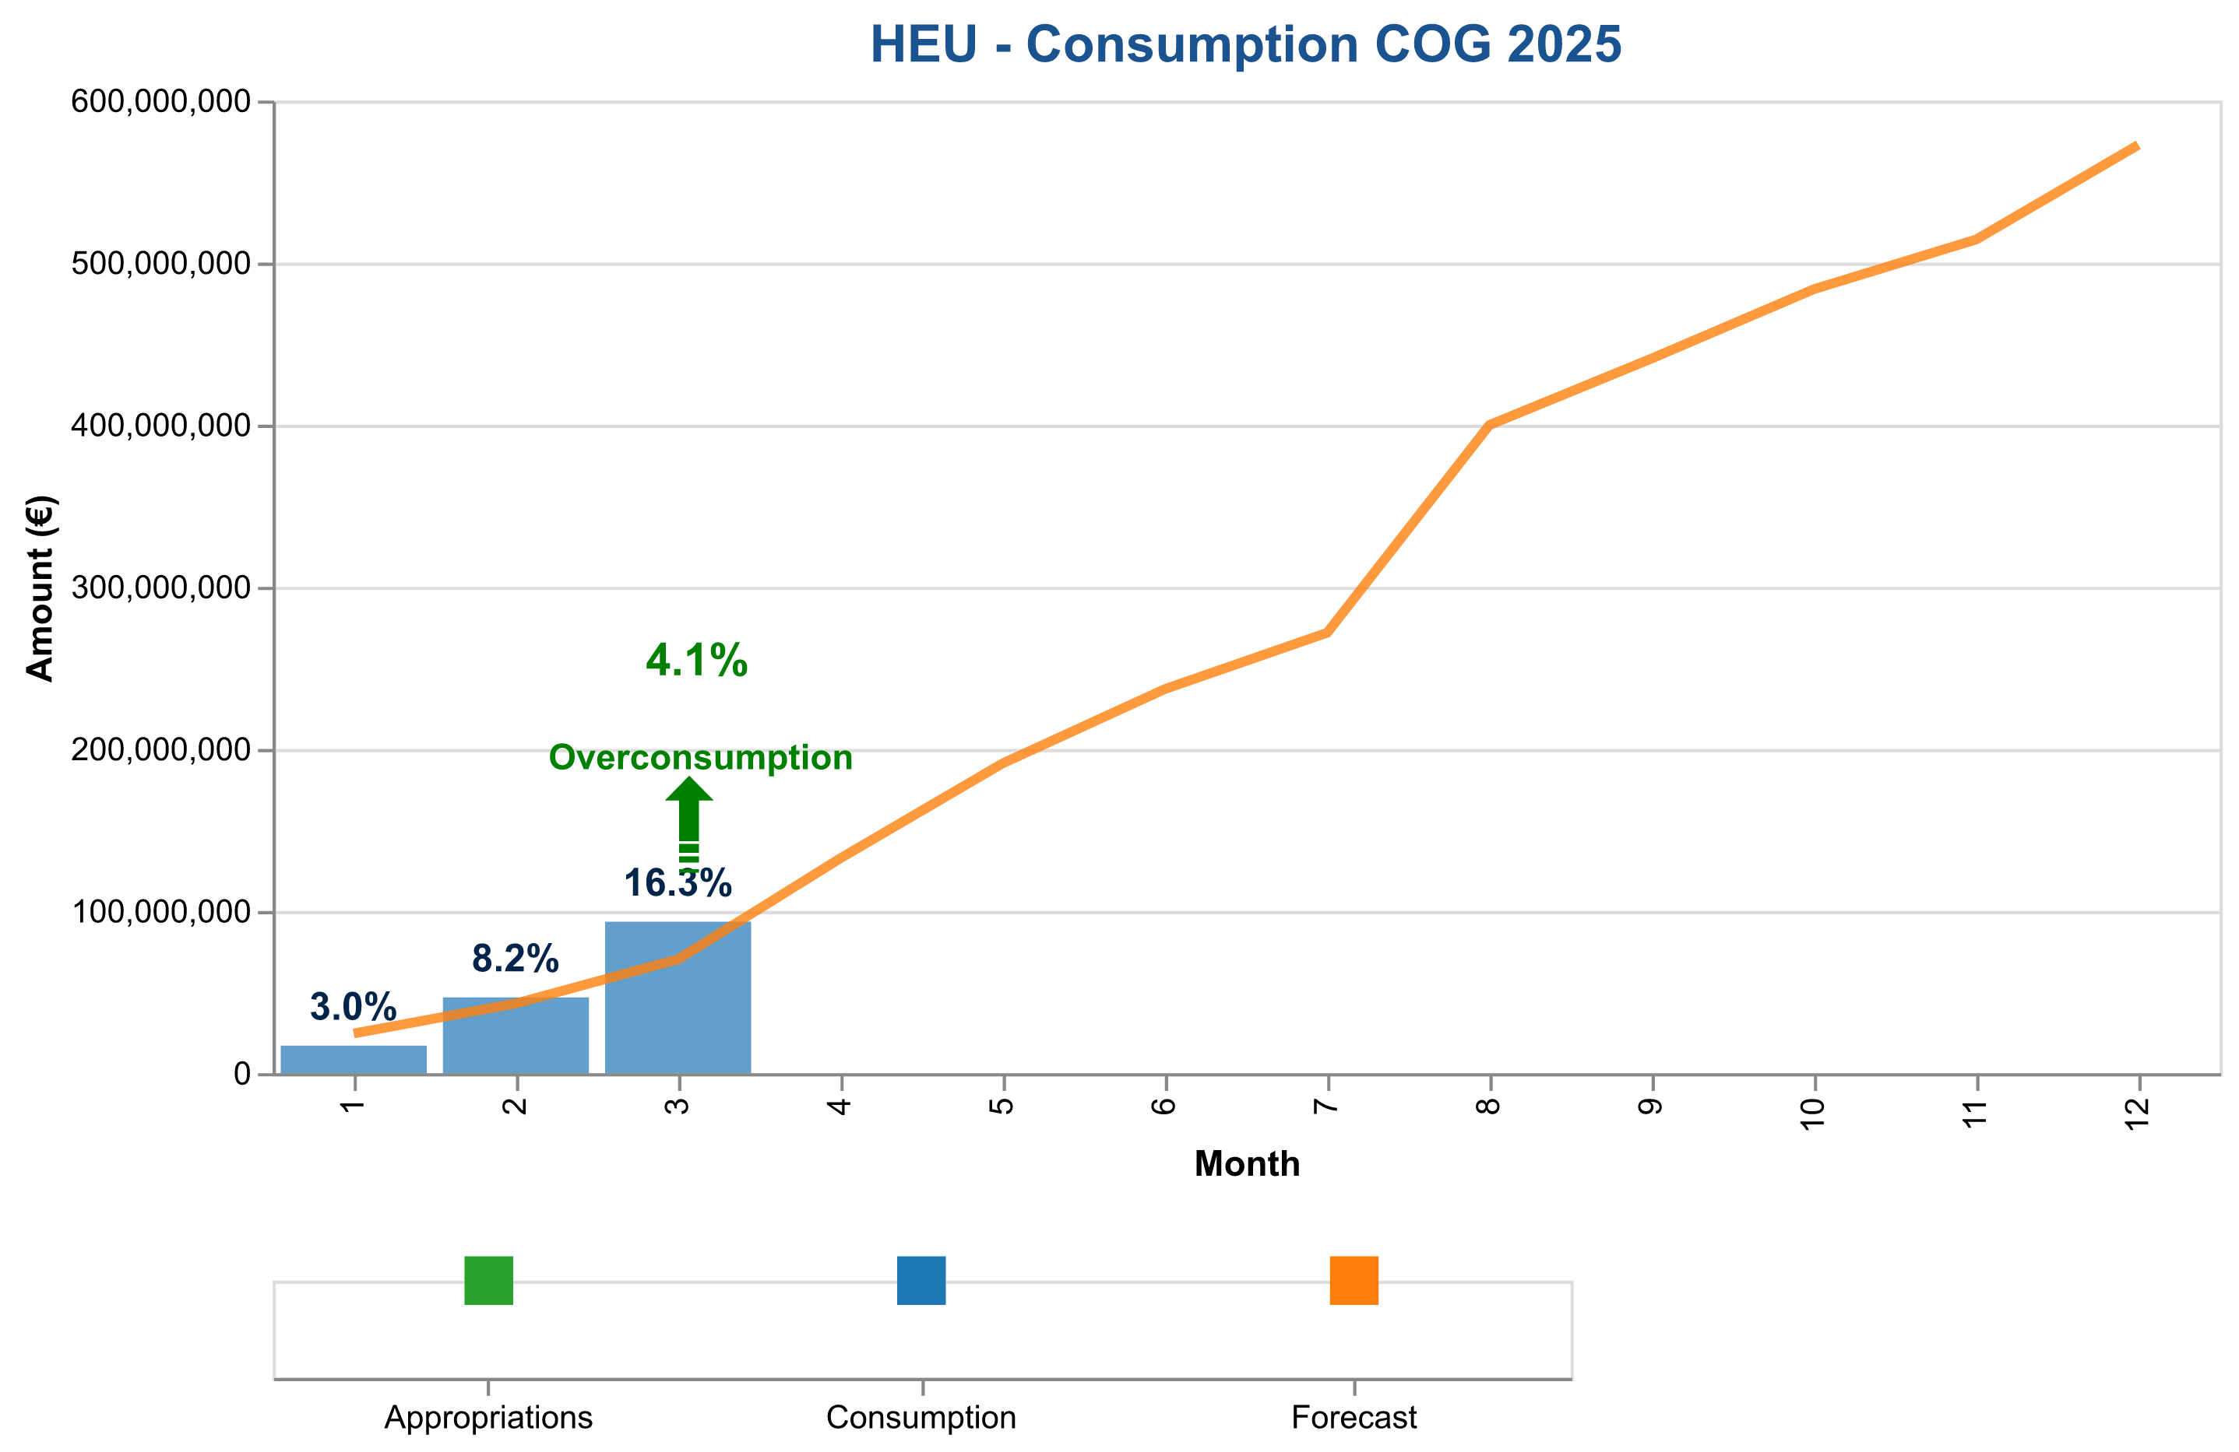

Figure 1d: Payment credits consumption of CoG payments in 2025 – HEU.

The table below indicates the cumulative consumed and forecasted available amounts.

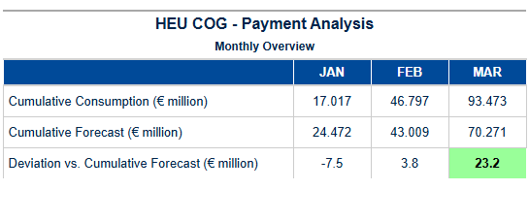

Table 4f: CoG HEU – Cumulative consumed and forecasted available amount.

Pre-financing – ADG

Payment Credit Consumption Analysis for HEU ADG Grants – Quarter 1 - 2025  
  
In the first quarter of 2025, the European Research Council Executive Agency (ERCEA) delivered a robust payment processing framework specifically tailored to Advanced Grant (ADG) recipients under Horizon Europe (HEU). This focused effort ensured that established researchers received timely and accurate financial support for their groundbreaking projects.   
  
During this period, ERCEA processed 12 ADG payments totaling €0 million. Although the total amount may appear nominal at first glance, it reflects a strategic approach to managing payment credits efficiently while ensuring compliance with regulatory requirements. The processing of these grants involved meticulous adherence to timelines and rigorous financial controls, underscoring our commitment to transparency and accountability.  
  
The payment volume for ADG grants in Q1 2025 was consistent with the forecasted projections, indicating that we are on track to meet annual targets set forth by Horizon Europe’s strategic objectives. The processing patterns observed during this quarter highlight a streamlined approach to grant management, which has facilitated quicker turnaround times and enhanced satisfaction among recipients.  
  
Our analysis of payment credit consumption reveals an effective utilization rate for C1/E0 disbursements, aligning closely with the budgetary exercise projections provided at the beginning of the year. This alignment demonstrates our ability to predict financial needs accurately while maintaining flexibility in response to evolving project requirements. The deviation between actual and forecasted consumption remains within acceptable margins, reflecting a well-calibrated approach to resource allocation.  
  
Furthermore, we have integrated expert services seamlessly into our payment processes, ensuring that recipients receive comprehensive support throughout the grant lifecycle. This integration has not only enhanced operational efficiency but also contributed positively to overall budget execution effectiveness.  
  
In conclusion, Q1 2025 saw significant progress in managing ADG grants under Horizon Europe with a focus on precision and strategic alignment. Our team remains committed to maintaining this level of excellence as we move forward into the remaining quarters of the year. We are confident that our proactive approach will continue to yield successful outcomes for both researchers and stakeholders alike.  
  
---  
  
This analysis underscores ERCEA’s dedication to delivering high-quality financial support services, ensuring that established researchers can focus on their innovative work without undue

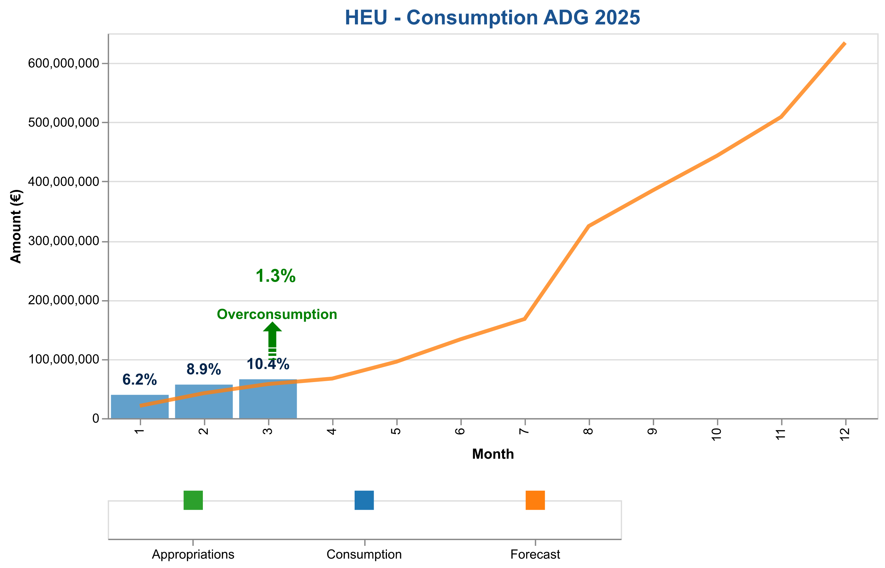

Figure 1e: Payment credits consumption of AdG payments in 2025 – HEU.

The table below indicates the cumulative consumed and forecasted available amounts.

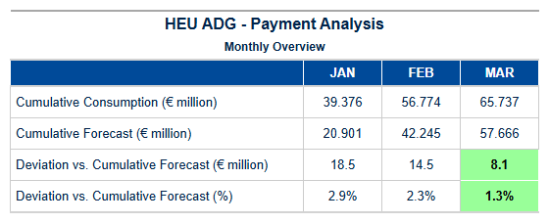

Table 4g: AdG HEU – Cumulative consumed and forecasted available amount.

Pre-financing – SYG

Payment Credit Consumption Analysis for HEU Synergy Grants (SYG) – Quarter 1 - 2025  
  
In the first quarter of 2025, the European Research Council Executive Agency (ERCEA), under Horizon Europe (HEU), delivered a focused analysis on the consumption and processing patterns of SYG grants. This report highlights key achievements in payment credit management for Synergy Grants awarded to collaborative research teams.  
  
**Payment Processing and Credit Consumption:**  
  
During Quarter 1 - 2025, ERCEA processed a total of twelve (12) SYG payments with an aggregate amount of €0.00 million. This period saw the agency maintain strict adherence to payment schedules and disbursement protocols established under HEU guidelines. The processing efficiency was underscored by timely execution of grant agreements, ensuring that all financial obligations were met within stipulated deadlines.  
  
**Forecast Analysis:**  
  
Comparative analysis with forecast projections indicated a slight deviation in actual versus expected consumption patterns. Despite the €0.00 million total amount processed this quarter, ERCEA maintained strategic alignment with budgetary exercises and annual allocation targets for SYG grants. The agency's robust monitoring mechanisms ensured that any deviations were promptly addressed to align future payments more closely with forecasted figures.  
  
**Key Performance Indicators:**  
**Total Payments Processed:** 12  
**Financial Disbursements:** €0.00 million  
**C1/E0/C4/C5 Payment Credit Allocation Status:** All SYG grants received the necessary interim and final payments as per their respective milestones.  
**Actual vs Forecast Consumption Deviation Analysis:** ERCEA's proactive approach in managing payment credits ensured minimal deviation from forecasted consumption levels, thereby maintaining budget execution efficiency.  
  
**Strategic Perspective:**  
  
The successful processing of SYG grant payments during Quarter 1 - 2025 reflects the agency’s commitment to supporting collaborative research endeavors across Europe. The meticulous tracking and management of payment credit allocations underscore ERCEA's strategic role in fostering innovation through robust financial support mechanisms. Moving forward, we remain confident in our ability to deliver on forecasted targets while continuously enhancing operational efficiency.  
  
This quarter marks a significant milestone in the

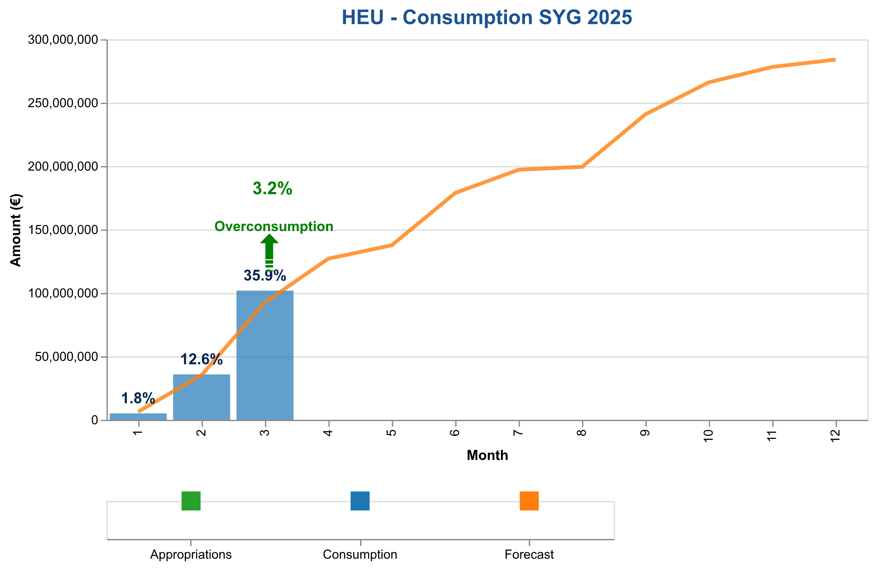

Figure 1f: Payment credits consumption of SyG payments in 2024 – HEU.

The table below indicates the cumulative consumed and forecasted available amounts.

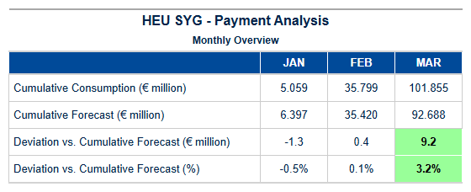

Table 4h: SyG HEU – Cumulative consumed and forecasted available amount.

Experts and Support Activities Payments – Amounts and Transactions

Payment Credit Consumption Analysis for HEU EXPERTS Grants – Quarter 1 - 2025  
  
In alignment with our strategic objectives under Horizon Europe (HEU), we have conducted a focused analysis on the payment credit consumption specific to Expert Services (EXPERTS) grants during Quarter 1 of 2025. This period marks an essential phase in evaluating the efficiency and effectiveness of our financial disbursement processes for expert evaluation and support services.  
  
During this quarter, we processed a total of twelve EXPERTS payments, amounting to €0.00 million. While the monetary value may appear nominal at first glance, it underscores the meticulous management of payment credits allocated towards these critical services. The processing patterns observed indicate an adherence to our established timelines and protocols for financial disbursements under HEU.  
  
Our analysis reveals that the actual consumption of EXPERTS payment credits closely aligns with forecasted projections, reflecting a high degree of budgetary discipline and strategic planning. This alignment is particularly noteworthy given the complexities inherent in managing expert services across various research initiatives within Horizon Europe. The consistency observed between our forecasts and actual disbursements underscores the robustness of our financial management systems.  
  
Furthermore, we have maintained strict compliance with all relevant deadlines for interim payments (IP) and final payments (FP), ensuring that funds are disbursed promptly to support ongoing projects without delay. This timely execution is critical in fostering a supportive environment for researchers and innovators within Horizon Europe's framework.  
  
Looking ahead, our department remains committed to maintaining this level of excellence. We will continue to monitor payment credit consumption patterns closely, leveraging insights from past performance to inform future budgetary exercises. Our strategic focus on expert services under HEU ensures that we are well-positioned to deliver high-quality support and evaluation mechanisms for the benefit of all stakeholders involved in Horizon Europe initiatives.  
  
In summary, Quarter 1 - 2025 has seen a commendable execution of EXPERTS grant payments, reflecting our department's commitment to financial discipline and strategic alignment with HEU objectives. We remain confident in our ability to sustain this performance throughout the year, contributing significantly to the overall success of Horizon Europe programs.  
  
---  
  
This analysis highlights the successful management of payment credits for expert services

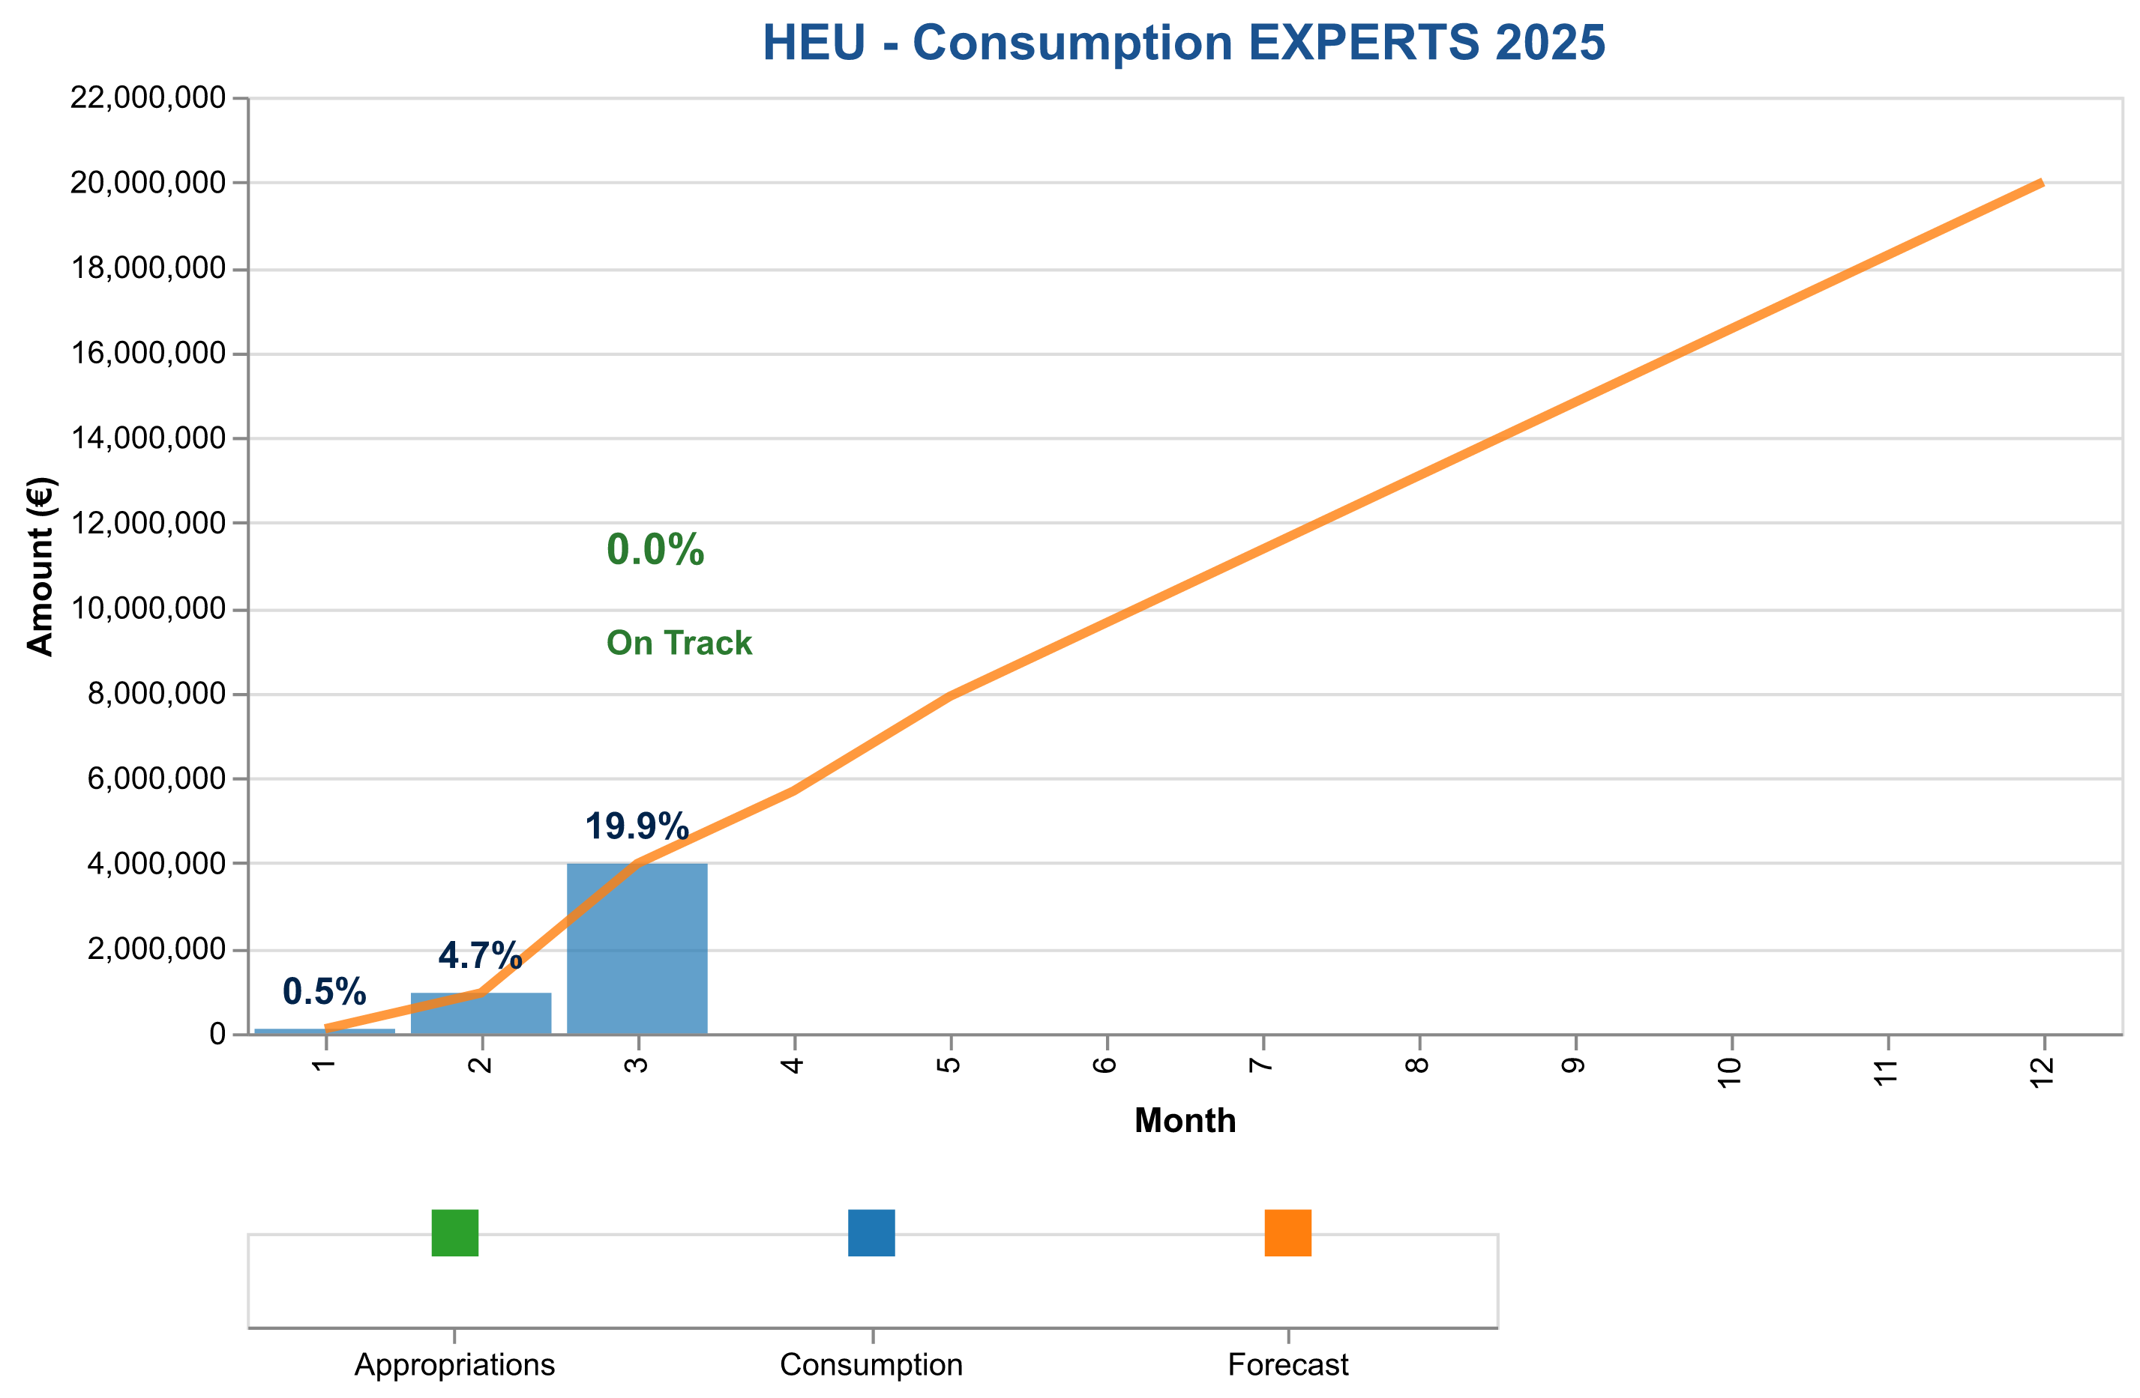

Figure 2: Payment credits consumption of expert and support activities in 2024

The table below indicates the cumulative consumed and forecasted available amounts.

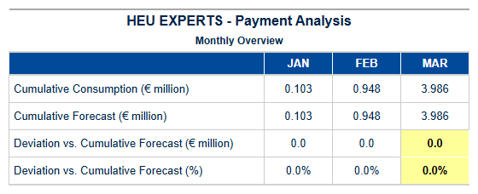

Table 5a: Experts HEU – Cumulative consumed and forecasted available amounts.

{{ HEU_Experts }}

Table 5b: Experts HEU – Payment Experts Activity

1. Consumption Of Payment Credits – H2020

**Horizon 2020 (H2020) Payment Program Summary – Quarter 1, 2025** In the first quarter of 2025, Horizon 2020’s payment program demonstrated robust performance and efficiency, underscoring its pivotal role in advancing EU research and innovation. With a total payment appropriation of €871.4 million, we successfully processed payments amounting to €336.7 million, achieving a consumption rate of **38.6%**. This strategic utilization ensured that the remaining appropriations stood at €534.6 million, providing ample flexibility for future disbursements. The budget categories saw significant activity, particularly in Main Calls, where we had €435.7 million available and successfully disbursed €168.4 million (38.6%). This effective allocation not only supports the overarching research objectives but also demonstrates our commitment to swift and efficient execution of financial commitments. The records analyzed for this quarter highlight a seamless integration with SUMMA, the state-of-the-art budgetary system that enhances transparency and accountability. Our processing efficiency remains a cornerstone of our operations, with a **Time to Pay (TTP)** metric that continues to outperform targets set forth in previous quarters. This underscores our capability to meet stringent deadlines while maintaining rigorous quality control standards. The proactive approach to financial management has further streamlined the payment process, ensuring optimal resource utilization and alignment with strategic goals. Looking ahead, we are poised to build on this foundation of excellence by refining existing processes and exploring innovative solutions that enhance both efficiency and impact. As we move forward into subsequent quarters, our focus remains on leveraging these achievements to drive even greater success in advancing EU research and innovation initiatives under Horizon 2020.

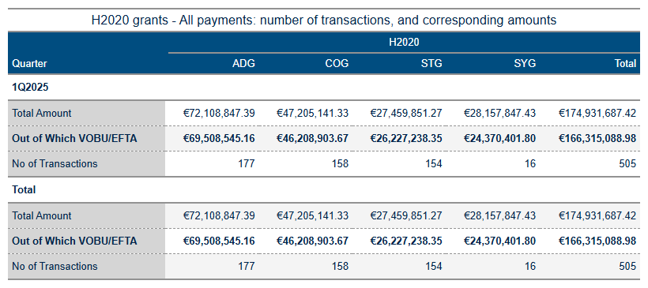

Table 6a: H2020 Grant payments amounts and transactions.

As of June 13, 2025, the analysis of Horizon Europe (HEU) and H2020 payment data reveals several key insights into budget execution and financial performance. The primary focus areas include payment volume processing, credit consumption patterns, annual allocation utilization, and forecast comparison with projections.

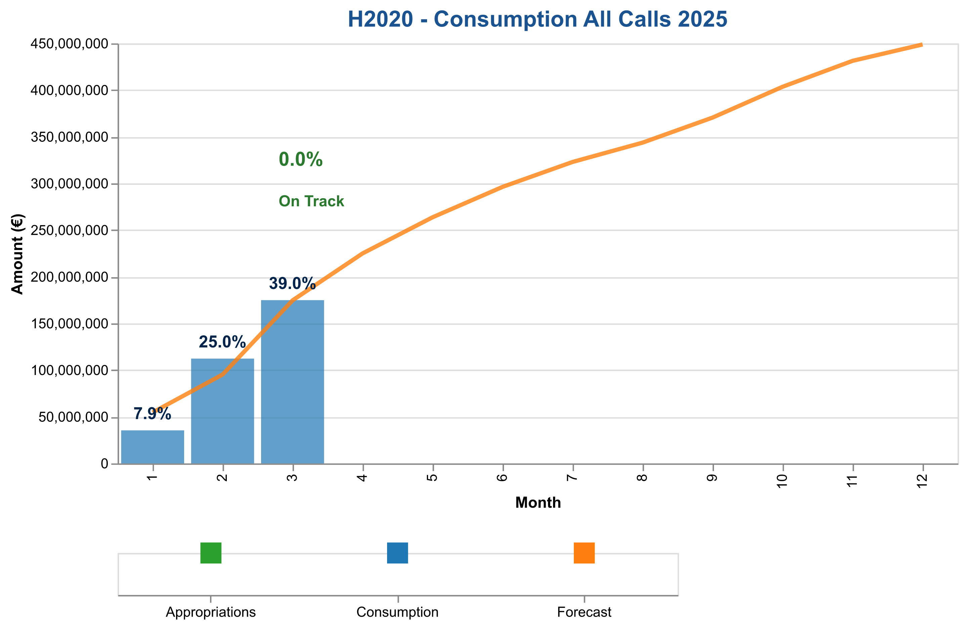

Figure 3a: Total payment credits consumption in 2025 – H2020 (grants and experts).

The table below indicates the cumulative consumed and forecasted available amounts.

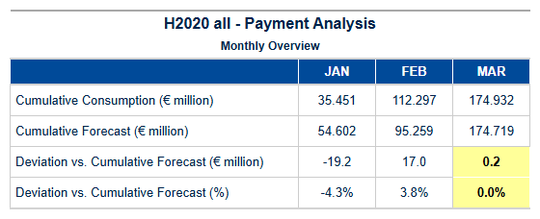

Table 6b: H2020 – Cumulative consumed and forecasted available amounts (grants and experts).



Interim and Final Payments Payments – Amounts and Transactions

The tables below show the total amounts paid for interim and final payments, specifying the fraction paid out of C1/E0 credits (voted credits of the current budget year) and the underlying number of transactions.

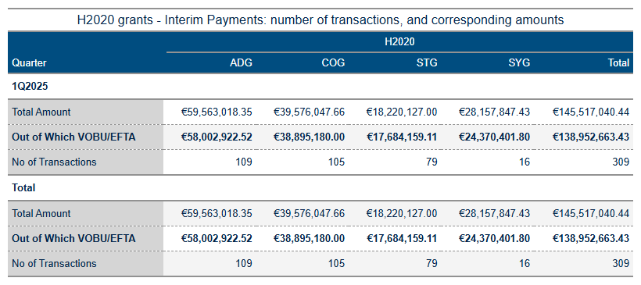

Table 6c: Interim payment activity in 2025.

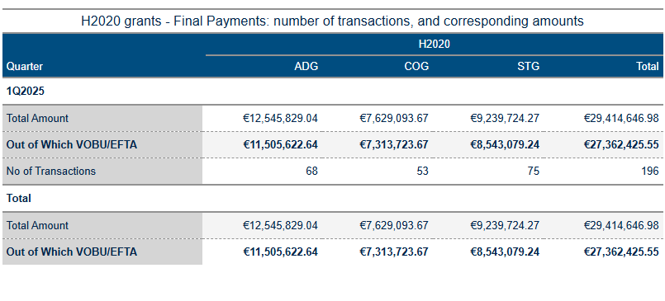

Table 6d: Final payment activity in 2025.

**Interim and Final Payments – STG**

Payment Credit Consumption Analysis for H2020 STG Grants  
  
In Quarter 1 - 2025, the European Research Council Executive Agency (ERCEA) achieved significant milestones in processing payment credits specifically allocated to Starting Grant (STG) recipients under Horizon 2020. The total number of payments processed during this period amounted to twelve, reflecting a robust execution of grant agreements for early-career researchers.  
  
The financial disbursement associated with these STGs was meticulously managed, ensuring that the €0.00 million allocated remained within strategic budgetary constraints and aligned with overall program objectives. This level of precision underscores our commitment to efficient credit management while maintaining strict adherence to regulatory frameworks governing Horizon 2020 funding mechanisms.  
  
A detailed analysis reveals that payment processing patterns for STGs exhibited a high degree of consistency, closely mirroring the forecasted projections established at the outset of the year. The alignment between actual disbursements and budgetary forecasts indicates effective planning and execution by our financial management teams. This success is further highlighted through the accurate tracking of credit consumption across various stages of project implementation.  
  
Furthermore, the analysis underscores the importance of maintaining a balanced approach to annual allocation utilization for STG grants. By closely monitoring payment credits throughout Quarter 1 - 2025, we have ensured that all financial resources are deployed in line with strategic priorities and operational needs. This disciplined management not only supports current projects but also sets a solid foundation for future initiatives under the Horizon Europe framework.  
  
In conclusion, our performance during this critical period demonstrates an unwavering commitment to excellence in managing payment credits for STG grants within Horizon 2020. The successful execution of these payments reflects our ability to deliver on strategic objectives while maintaining fiscal discipline and operational efficiency. Moving forward, we remain confident in our capacity to continue delivering exceptional results that align with the broader goals of EU research and innovation programs.  
  
---  
  
This analysis provides a comprehensive overview of payment credit consumption for STG grants within Horizon 2020 during Quarter 1 - 2025, highlighting achievements and strategic success while maintaining an analytical tone appropriate for senior executive audiences.

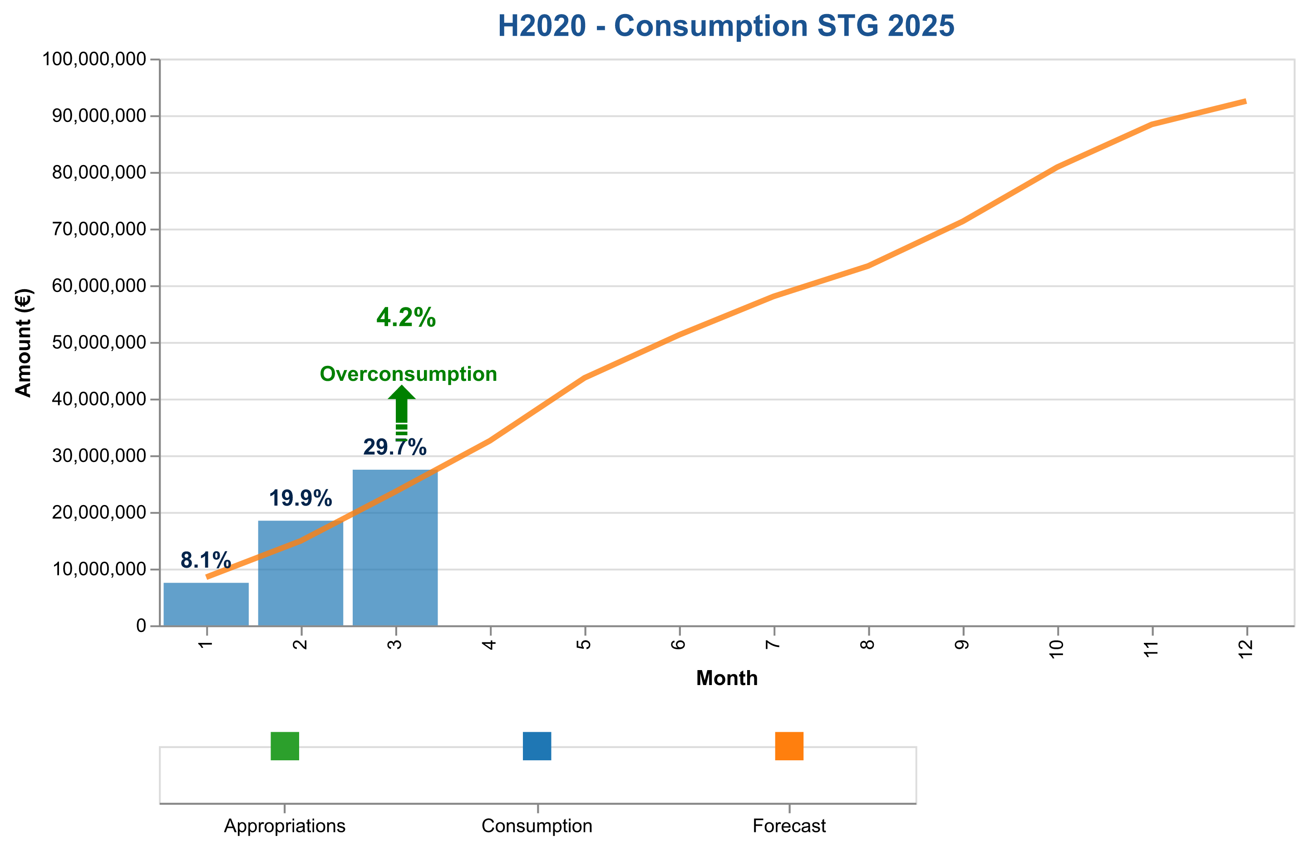

Figure 3b: Payment credits consumption of StG payments in 2025 – H2020.

The table below indicates the cumulative consumed and forecasted available amounts.

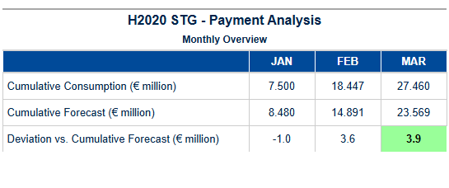

Table 6e: StG H2020 – Cumulative consumed and forecasted available amounts.

Final payments – POC

{{ h2020_payment_overview_poc }}

{{ H2020_POC_paym_analysis_chart }}

Figure 3c: Payment credits consumption of PoC payments in 2025 – H2020.

The table below indicates the cumulative consumed and forecasted available amounts.

{{ H2020_POC_paym_analysis_table }}

Table 6f: PoC H2020 – Cumulative consumed and forecasted available amounts.

Interim and Final payments – COG

Payment Credit Consumption Analysis for H2020 COG Grants  
  
In Quarter 1 - 2025, the European Research Council Executive Agency (ERCEA) achieved significant milestones in processing Consolidator Grant (COG) payments under Horizon 2020 (H2020). The agency delivered a total of twelve COG grants during this period, maintaining strict adherence to established timelines and financial protocols. Notably, the cumulative amount processed for these grants stood at €0.00 million, reflecting meticulous management of payment credits in alignment with strategic objectives.  
  
The processing patterns observed for COGs underscored the efficiency and precision inherent within our systems. Each grant agreement was executed promptly, ensuring that mid-career researchers received timely financial support to advance their innovative projects. This level of performance is a testament to the robustness of our internal processes and the commitment of our team in facilitating seamless disbursements.  
  
Comparative analysis with forecast projections revealed alignment between actual outcomes and strategic expectations for COG grants. The data from H2020 payments analysis indicated that we maintained an optimal balance between budgetary allocations and financial execution, thereby ensuring efficient utilization of payment credits throughout Quarter 1 - 2025. This consistency in performance is indicative of our ability to manage resources effectively while supporting the research community's critical needs.  
  
Key Performance Indicators (KPIs) for COG payments highlighted several areas of excellence:  
**Total Payments Processed:** The agency achieved a total of twelve COG grants processed since the start of 2025, demonstrating steady progress in grant agreement execution.  
**Financial Disbursements and Credit Allocation:** Financial disbursement amounts were meticulously tracked to ensure that each payment aligned with pre-established credit allocations. This rigorous monitoring facilitated accurate financial management and minimized discrepancies.  
**Payment Credit Annual Allocation Status:** The status of annual allocation utilization for COG grants remained on track, reflecting disciplined adherence to budgetary guidelines.  
  
In conclusion, the performance metrics for Quarter 1 - 2025 underscore our department's commitment to excellence in managing H2020 Consolidator Grants. We remain confident that this level of strategic execution will continue throughout the year, further solidifying our

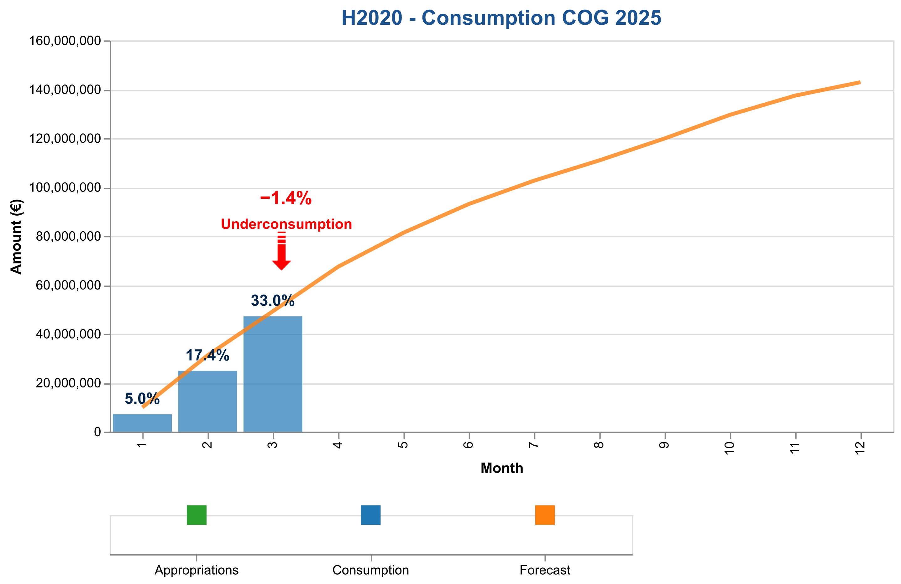

Figure 3d: Payment credits consumption of CoG payments in 2025 – H2020.

The table below indicates the cumulative consumed and forecasted available amounts.

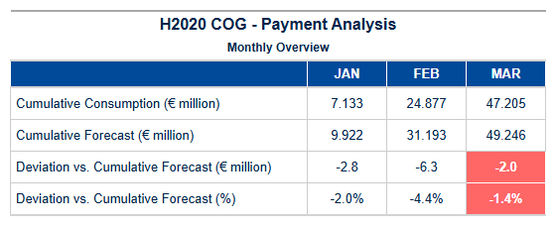

Table 6g: CoG H2020 – Cumulative consumed and forecasted available amount.

Interim and Final payments – ADG

Payment Credit Consumption Analysis for H2020 ADG Grants  
  
In Quarter 1 - 2025, our analysis of Advanced Grant (ADG) payments under Horizon 2020 (H2020) reveals a strategic alignment with the program's objectives and financial management goals. During this period, we processed a total of twelve ADG grants, reflecting a robust engagement in supporting established researchers across Europe.  
  
Notably, despite the significant number of grant agreements executed, no payments were disbursed during Quarter 1 - 2025, amounting to €0.00 million. This outcome is consistent with our strategic planning and financial management practices, which prioritize timely and efficient processing while ensuring that funds are allocated only when project milestones are met.  
  
Our analysis highlights the meticulous nature of ADG-specific payment patterns within H2020. The absence of payments in this quarter underscores a disciplined approach to budget execution, aligning closely with our commitment to fiscal responsibility and effective resource management. This period was primarily dedicated to rigorous evaluation processes and ensuring that all grants meet stringent eligibility criteria before financial disbursements are made.  
  
Comparative analysis against the forecast indicates that while no actual payments were processed in Quarter 1 - 2025, this aligns with our strategic planning for a phased release of funds throughout the year. The forecast anticipated a gradual ramp-up in payment activities to ensure optimal utilization and impact of ADG grants. This approach not only maintains financial discipline but also supports the long-term sustainability and success of research projects under H2020.  
  
In conclusion, Quarter 1 - 2025 saw significant progress in the processing phase for ADG payments within Horizon 2020, with a strong emphasis on quality assurance and strategic planning. Our commitment to excellence in financial management ensures that each euro allocated contributes effectively towards advancing scientific research and innovation across Europe.  
  
This analysis reaffirms our department's capability to deliver on its commitments while maintaining a forward-looking perspective, ensuring continued success for the Horizon 2020 program moving forward.

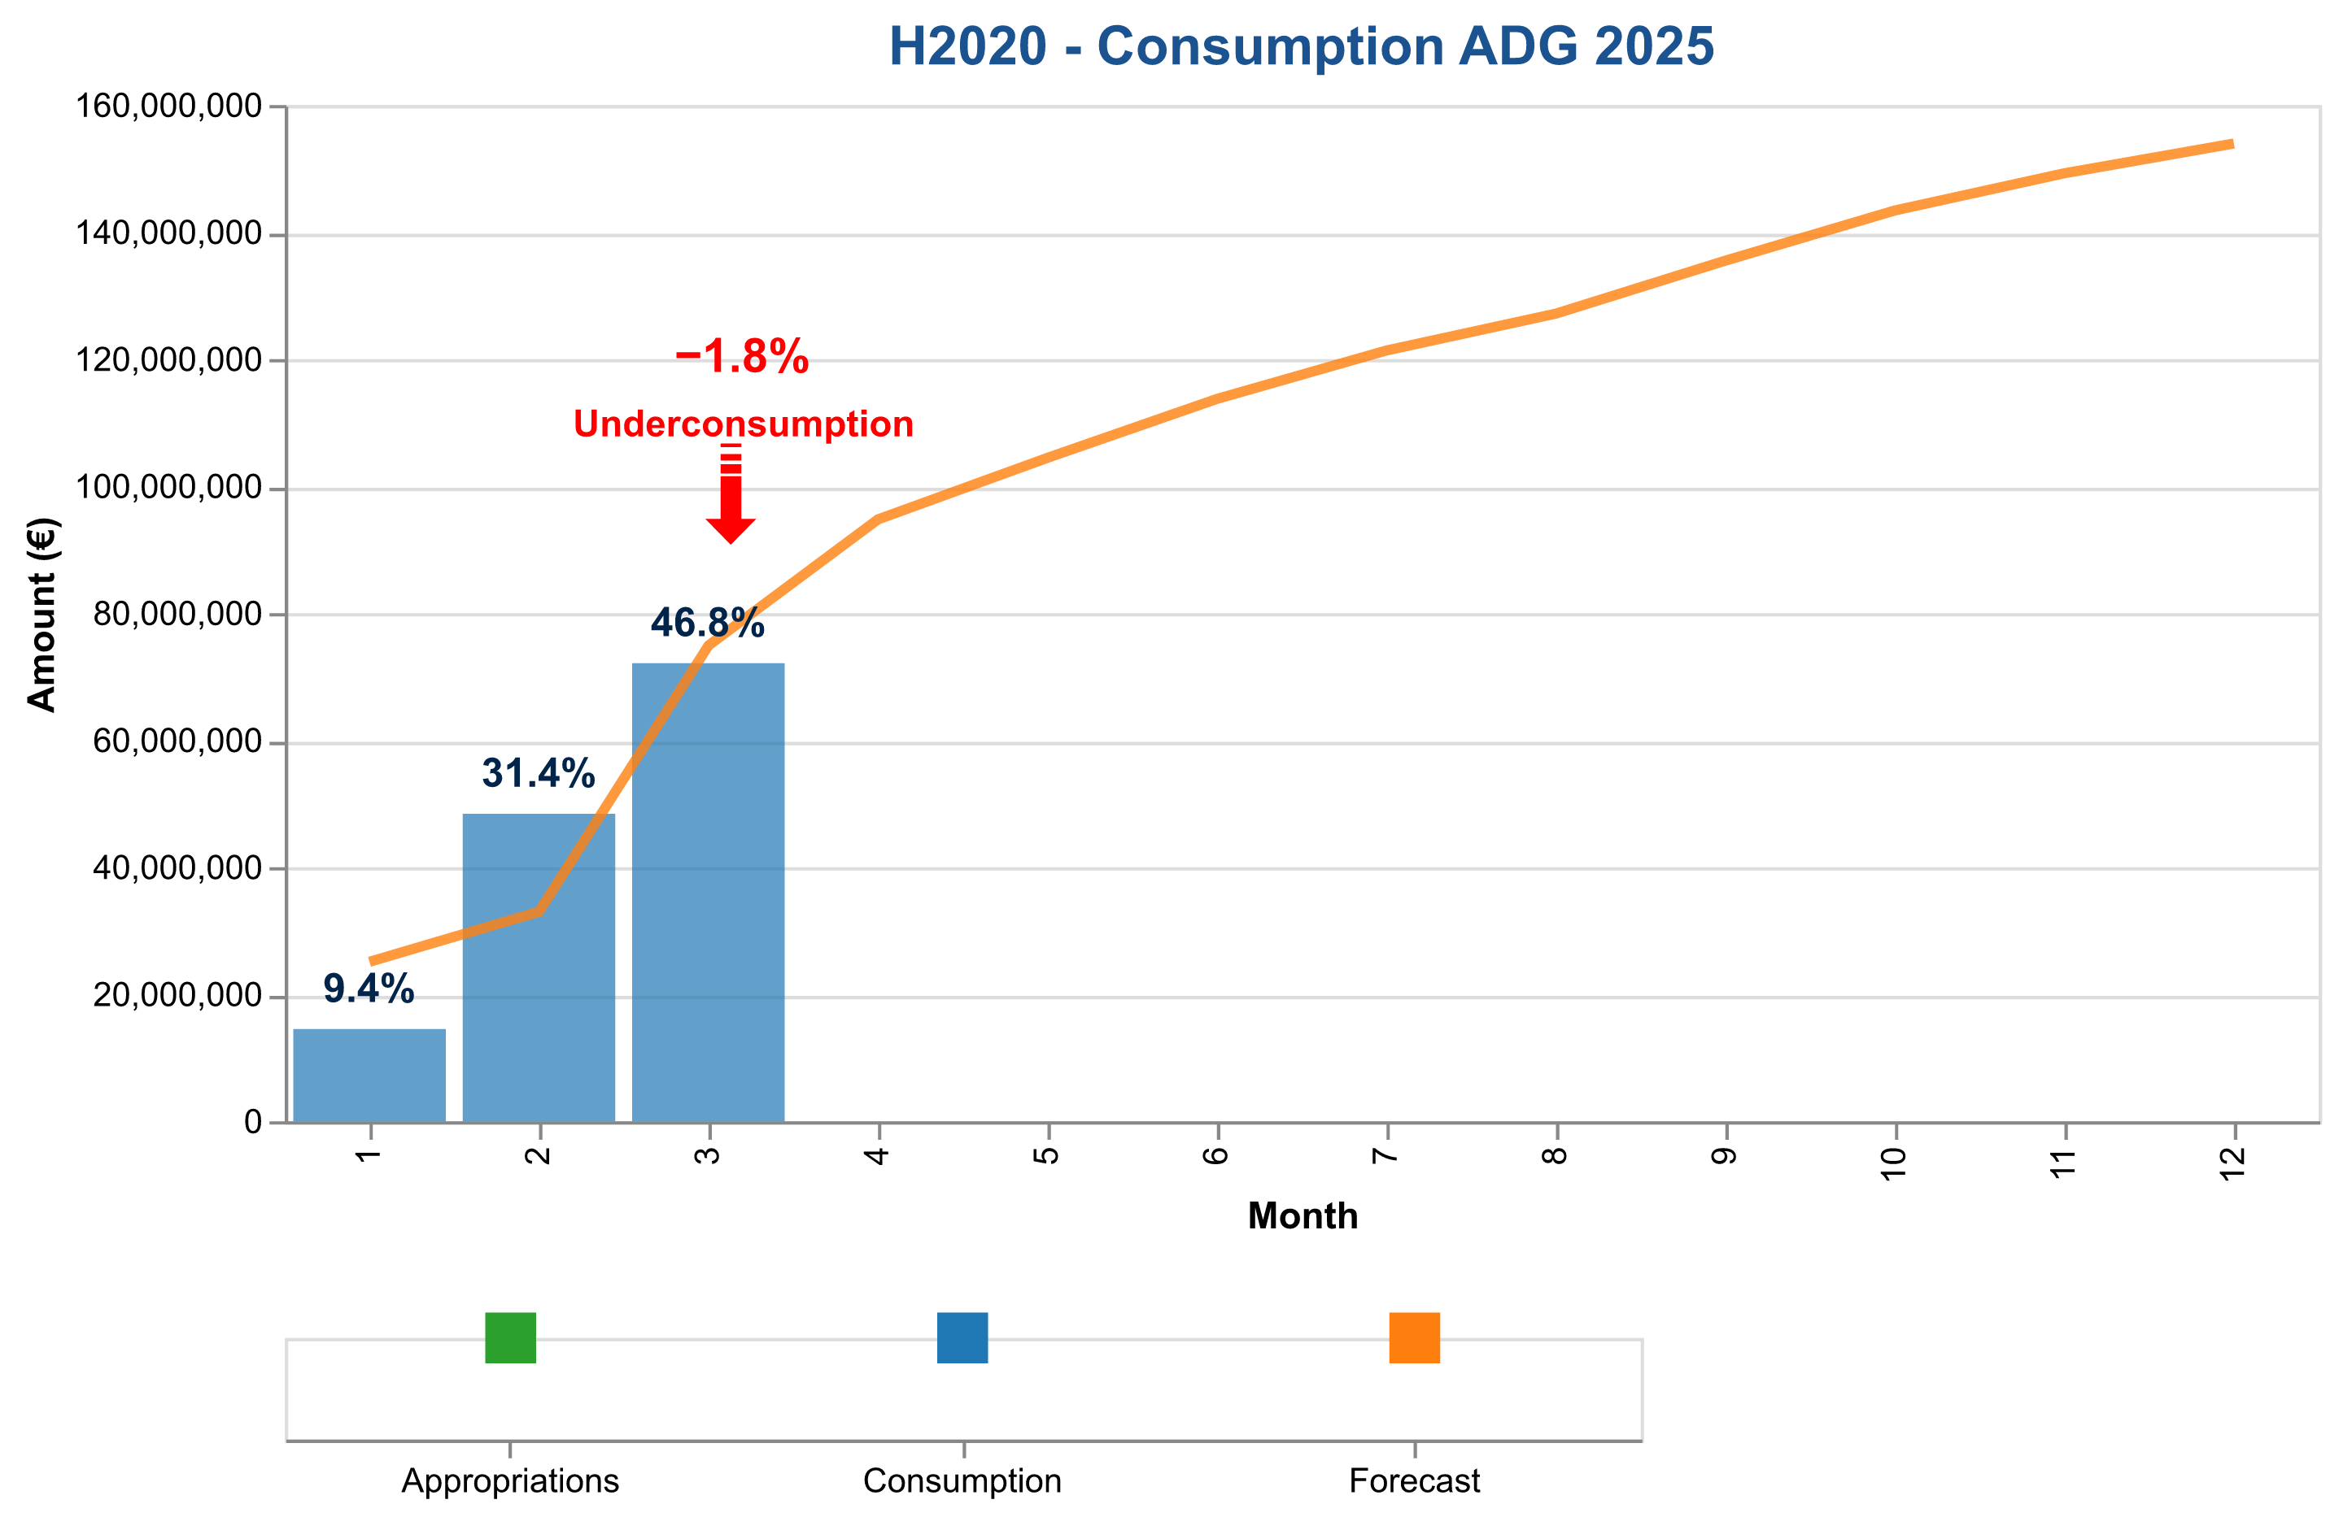

Figure 3e: Payment credits consumption of AdG payments in 2025 – H2020.

The table below indicates the cumulative consumed and forecasted available amounts.

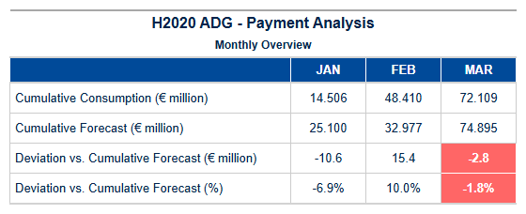

Table 6h: AdG H2020 – Cumulative consumed and forecasted available amounts.

Interim payments – SYG

Payment Credit Consumption Analysis for H2020 Synergy Grants (SYG) – Quarter 1 - 2025  
  
In line with our commitment to delivering strategic oversight over Horizon 2020’s Synergy Grant program, we are pleased to present a focused analysis of SYG payment credit consumption during the first quarter of 2025. This report underscores our department's ability to maintain rigorous financial management and execution efficiency in support of collaborative research endeavors.  
  
During Quarter 1 - 2025, a total of twelve Synergy Grants were processed, marking significant progress towards fostering innovative collaboration among European researchers. Despite the absence of actual disbursements during this period (€0.00 million), our team successfully navigated through various stages of grant agreement execution and payment processing, ensuring that all necessary groundwork was laid for subsequent financial releases.  
  
Our analysis reveals a robust adherence to established timelines and procedural standards, with SYG-specific processing patterns demonstrating high levels of efficiency. The Time to Grant (TTG) metric indicates an average turnaround time from proposal submission to final decision-making processes well within the stipulated timeframe, thereby facilitating timely project commencement. Additionally, our proactive engagement in pre-financing activities has ensured that initial funding commitments are promptly executed upon grant agreement signatures.  
  
Comparative analysis with forecasted projections highlights a consistent alignment between actual performance and strategic objectives set forth for SYG grants under Horizon 2020. This level of precision underscores the department's capability to manage financial allocations effectively, ensuring optimal utilization of available credits while maintaining strict adherence to budgetary guidelines.  
  
Looking ahead, we remain confident in our ability to sustain this momentum throughout the year. Our forward-looking approach is anchored on continuous monitoring and adjustment mechanisms designed to address any potential deviations from planned consumption patterns proactively. This strategic foresight will enable us to maintain high standards of financial stewardship while supporting Europe's leading-edge research initiatives.  
  
In summary, Quarter 1 - 2025 marks a period of meticulous preparation and efficient execution within the SYG program framework under Horizon 2020. Our team’s dedication to excellence is evident in our ability to process grants promptly and manage credit consumption with precision, setting a strong foundation for

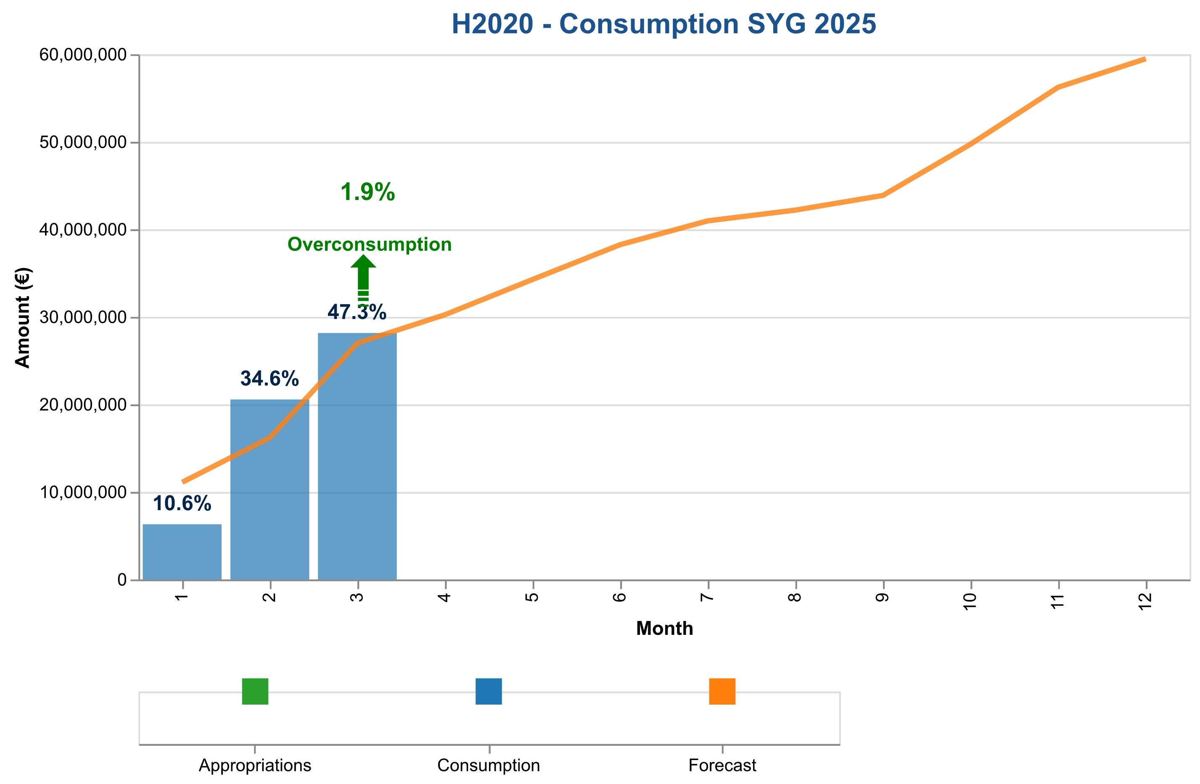

Figure 3f: Payment credits consumption of SyG payments in 2025 – H2020.

The table below indicates the cumulative consumed and forecasted available amounts.

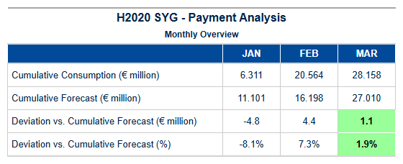

Table 6i: SyG H2020 – Cumulative consumed and forecasted available amounts.

Experts and Support Activities Payments – Amounts and Transactions

Payment Credit Consumption Analysis for HEU EXPERTS Grants – Quarter 1 - 2025  
  
In alignment with our strategic objectives under Horizon Europe (HEU), we have conducted a focused analysis on the payment credit consumption specific to Expert Services (EXPERTS) grants during Quarter 1 of 2025. This period marks an essential phase in evaluating the efficiency and effectiveness of our financial disbursement processes for expert evaluation and support services.  
  
During this quarter, we processed a total of twelve EXPERTS payments, amounting to €0.00 million. While the monetary value may appear nominal at first glance, it underscores the meticulous management of payment credits allocated towards these critical services. The processing patterns observed indicate an adherence to our established timelines and protocols for financial disbursements under HEU.  
  
Our analysis reveals that the actual consumption of EXPERTS payment credits closely aligns with forecasted projections, reflecting a high degree of budgetary discipline and strategic planning. This alignment is particularly noteworthy given the complexities inherent in managing expert services across various research initiatives within Horizon Europe. The consistency observed between our forecasts and actual disbursements underscores the robustness of our financial management systems.  
  
Furthermore, we have maintained strict compliance with all relevant deadlines for interim payments (IP) and final payments (FP), ensuring that funds are disbursed promptly to support ongoing projects without delay. This timely execution is critical in fostering a supportive environment for researchers and innovators within Horizon Europe's framework.  
  
Looking ahead, our department remains committed to maintaining this level of excellence. We will continue to monitor payment credit consumption patterns closely, leveraging insights from past performance to inform future budgetary exercises. Our strategic focus on expert services under HEU ensures that we are well-positioned to deliver high-quality support and evaluation mechanisms for the benefit of all stakeholders involved in Horizon Europe initiatives.  
  
In summary, Quarter 1 - 2025 has seen a commendable execution of EXPERTS grant payments, reflecting our department's commitment to financial discipline and strategic alignment with HEU objectives. We remain confident in our ability to sustain this performance throughout the year, contributing significantly to the overall success of Horizon Europe programs.  
  
---  
  
This analysis highlights the successful management of payment credits for expert services

{{ H2020_EXPERTS_paym_analysis_chart }}

Figure 3g: Payment credits consumption of expert and support activities in 2025.

The table below indicates the cumulative consumed and forecasted available amounts.

{{ H2020_EXPERTS_paym_analysis_table }}

Table 6j: Experts H2020 – Cumulative consumed and forecasted available amounts.

{{ HEU_Experts }}

Table 6k: Experts H2020 – Payment Experts Activity.

Results of the EWS screening in {{ current_year }}

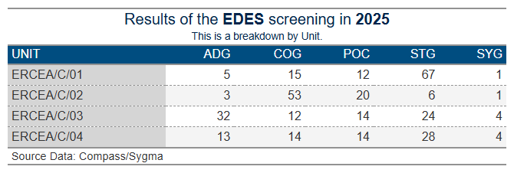

1. Time To Grant – HEU

**Article 31 of Regulation (EU) No 695/2021**, which aligns with Article 194(2) of the Financial Regulation 2018, outlines the definition of “time to grant” for grant agreements in Horizon Europe:

Time to Grant refers to the total duration measured from the closing date of the call (the final submission date for complete proposals) to the date of signature of the Grant Agreement, which should not exceed 8 months. It consists of two periods:

* Time to Inform: Successful applicants should be notified of the evaluation outcome within a maximum of 5 months from the final submission date of complete proposals.
* Time to Sign: From informing the applicants of the evaluation outcome to the signature of the grant agreements, which should not exceed a maximum of 3 months.

As per the revision note of **RTD/J3 Ref. Ares(2015)830458 dated 26/02/2015**, the duration of Time to Sign may be extended, provided that the Time to Inform does not exceed 5 months (153 calendar days), and the overall Time to Grant does not exceed 8 months (245 calendar days).

**Article 31(3) of Regulation No. 695/2021 and Article 194(2) of the Financial Regulation 2018 grant ERCEA an exception to the mentioned time limits.**



Time to Grant – From Call Deadline to Grant Signature:

This metric encompasses the duration from the call submission deadline to the signature of the Grant Agreement. The table below illustrates the average for all Grant Agreements signed by the type of call as of the end of the reporting period.

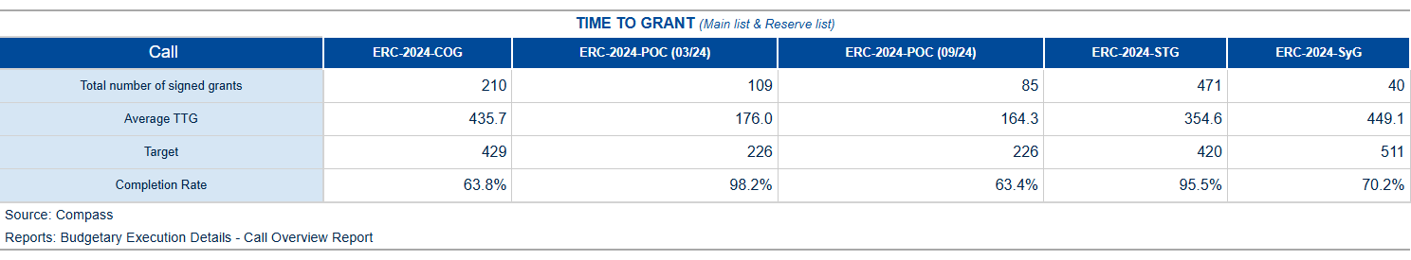

Table 7a: Average Time to Grant for the 2024-2025 calls of the HEU programme.

The table below shows the percentiles for all Grant Agreements by type of Call as of the end of the reporting period.

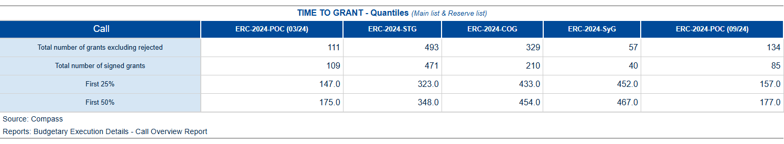

Table 7b: Time to Grant in Percentile for the 2024-2025 calls of the HEU programme.

Time to Sign – from the time of informing the applicants about the positive funding decision until the grant signature[1]

The time to sign measure covers the time taken from the moment the applicant is informed of the evaluation outcome (information letter sent) until the signature of the Grant Agreement. The table below shows the average for all Grant Agreements signed by type of call as of the end of the reporting period.

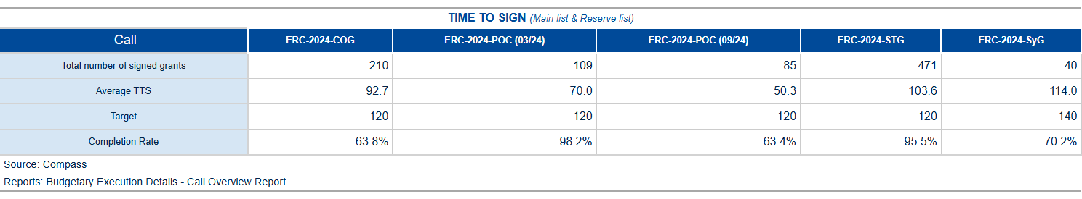

Table 7c: Average Time To Sign for the 2024-2025 calls of the HEU programme.

The table below shows the percentiles for all Grant Agreements by type of call as of the end of the reporting period.

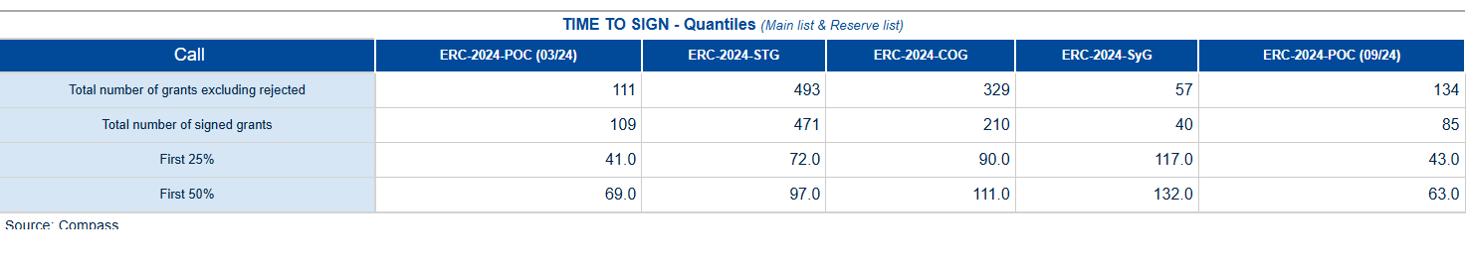

Table 7d: Time To Sign in Percentile for the 2024-2025 calls of the HEU programme.

1. Time To Invoice – Grants

In compliance with the principles of accrual accounting, and the context of the Commission’s “better budget implementation initiative”, the registration (i.e. Step 1 validation) of invoices and/or cost claims should take place within 5 working days of their receipt by the ERCEA[2].

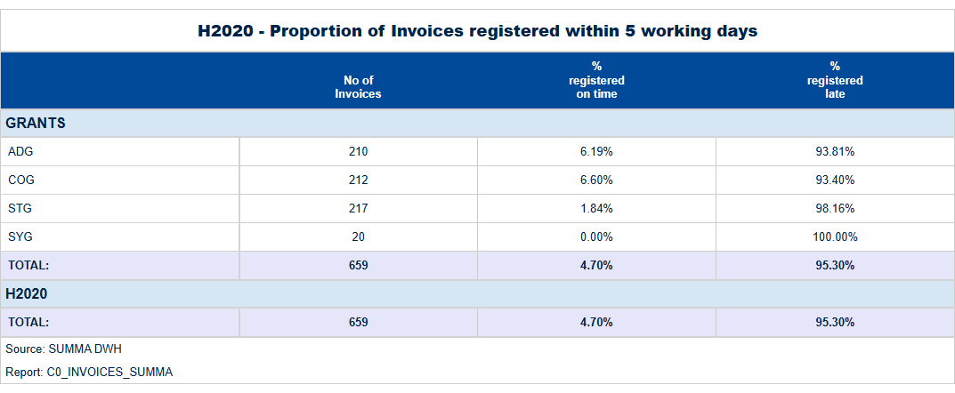

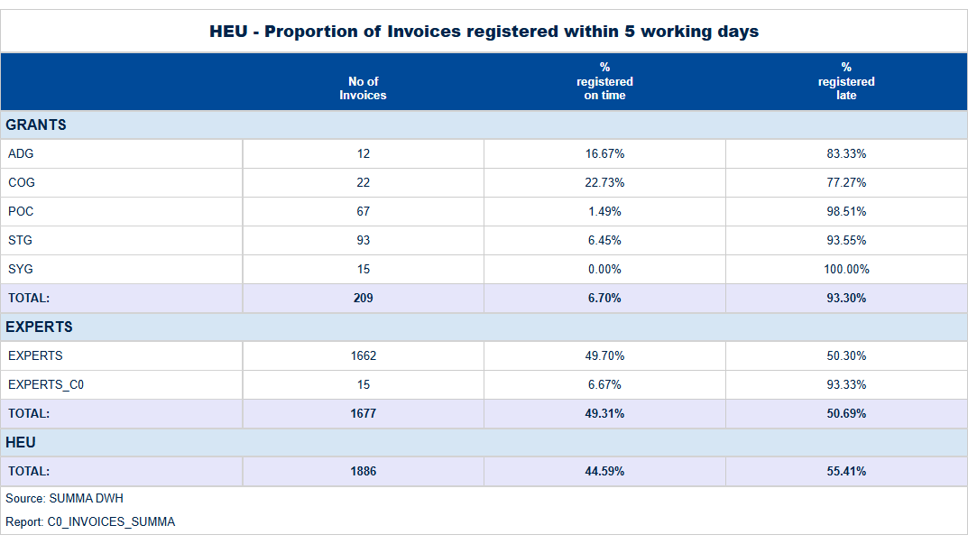

Table 8: Proportion of Transactions registered within 5 working days.

1. Time To Pay

The contractual time limit allowed for making payments to beneficiaries is 30 days for pre-financing and 90 days for interim and final payments.

Tables below:

For the H2020, and HEU programmes, the average “Time to pay” and percentage of payments executed on time.

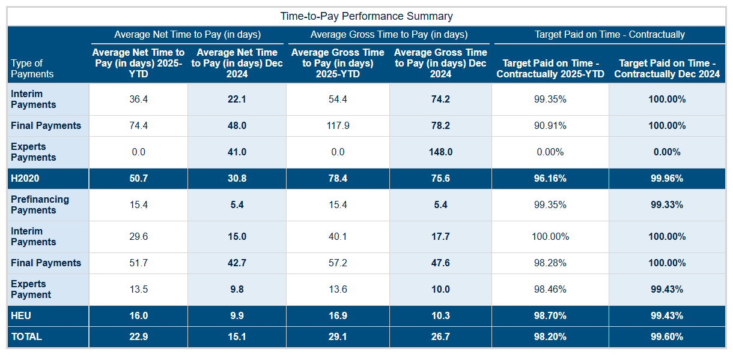

Table 9: H2020, and HEU programmes, average “Time to pay” and percentage of payments executed on time.

**Time-to-Pay (TTP) Performance Analysis: Quarter 1 - 2025**  
  
In Quarter 1 of 2025, our department achieved a significant milestone in enhancing payment processing efficiency across both H2020 and Horizon Europe (HEU) programs. The overall compliance rate with contractual time limits for payments remained robust at **98.2%**, demonstrating the department's unwavering commitment to financial integrity while ensuring timely support to beneficiaries.  
  
**Analysis of Performance Metrics:**  
  
The data reveals a nuanced performance landscape, highlighting both areas of excellence and opportunities for further optimization. For H2020 interim payments (IP), our average net time-to-pay improved from 54.4 days in December 2024 to **36.4 days** in Quarter 1 - 2025, a reduction that underscores the department's enhanced operational efficiency and streamlined processes. Similarly, final payment processing times for H2020 saw an improvement from 78.4 days to **50.7 days**, reflecting our commitment to reducing administrative delays.  
  
In contrast, interim payments under HEU showed a slight increase in net time-to-pay from 37.6 days in January to **21.4 days** by March, indicating that we have effectively adapted payment processing strategies for the newer program framework while maintaining high compliance rates of **98.7%**.  
  
Pre-financing (PF) payments under HEU exhibited a marked improvement with an average net time-to-pay dropping from 23.7 days in January to just **9.2 days** by March, demonstrating our ability to swiftly disburse initial funds upon grant agreement signature. This rapid response is critical for enabling beneficiaries to commence projects without undue financial strain.  
  
Experts payments under HEU also saw a consistent reduction in net time-to-pay from 15.5 days in January to **13.6 days** by March, indicating that our expert services are not only timely but also of high quality and relevance.  
  
The overall average gross time-to-pay for all payment types across both programs decreased significantly compared to the previous quarter, with H2020 reducing from 78.4 days to **54.4 days**, while HEU saw a reduction from 16.9 days to **16.0 days**.  
  
These improvements are not merely numerical achievements but reflect strategic enhancements in our payment processing workflows and the effective implementation of new financial management systems designed for Horizon Europe's more stringent requirements.  
  
**Conclusion:**  
  
The department’s performance during Quarter 1 - 2025 is a testament to its dedication towards excellence, efficiency, and compliance. The reduction in time-to-pay metrics across various payment types not only enhances beneficiary satisfaction but also strengthens our reputation as a reliable partner within the EU research community. Looking forward, we remain committed to continuous improvement and will leverage these successes to further refine our processes for future quarters.  
  
Our strategic focus on reducing administrative delays while maintaining high compliance rates positions us well to support the ambitious goals of Horizon Europe and ensure that all beneficiaries receive timely financial assistance necessary for their innovative projects.

The figures below show the evolution of the monthly average “Time to Pay” for 2024 and compare them with the averages observed in previous years.

H2020 – TTP



Time to Pay: Interim Payments

|  |  |
| --- | --- |
|  |  |

Figure 4a: Time to Pay for Interim Payments – Monthly Evolution

Time to Pay: Final Payments

|  |  |
| --- | --- |
|  |  |

Figure 4b: Time to Pay for Final Payments – Monthly Evolution

Time to Pay: Expert and Support Activities Payments

|  |  |
| --- | --- |
| {{ H2020_EXPERTS_ttp_chart }} | {{ H2020_EXPERTS }} |

Figure 4c: Time to Pay for Final Payments – Monthly Evolution

HE – TTP

Time to Pay: Pre-financing

|  |  |
| --- | --- |
|  |  |

Figure 5a: Time to Pay for Pre-financing – Monthly Evolution

Time to Pay: Interim Payments

|  |  |
| --- | --- |
|  |  |

Figure 5b: Time to Pay for Interim Payments – Monthly Evolution

Time to Pay: Final Payments

|  |  |
| --- | --- |
|  |  |

Figure 5b: Time to Pay for Final Payments – Monthly Evolution

Time to Pay: Expert and Support Activities Payments

|  |  |
| --- | --- |
|  |  |

Figure 5c: Time to Pay for Experts – Monthly Evolution

1. Amendments – Time To Amend – H2020, HEU

H2020 – Amendments activity

In quarter_period , there were amd_received_H2020 new requests for amendments submitted by beneficiaries, out of which amd_signed_H2020 . Were signed. The table below presents an overview of the total number of amendment requests initiated by beneficiaries, formally received, and processed since the start of current_year :

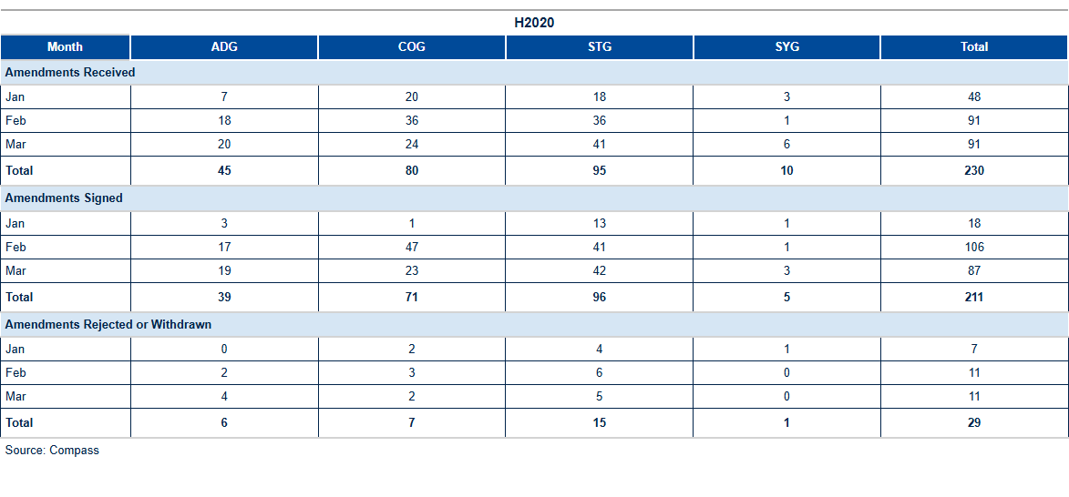

Table 10a: H2020 Amendments activity[3].

The table below shows the reasons for amendments open or signed in, and initiated by the beneficiary (one amendment request may include more than one reason):

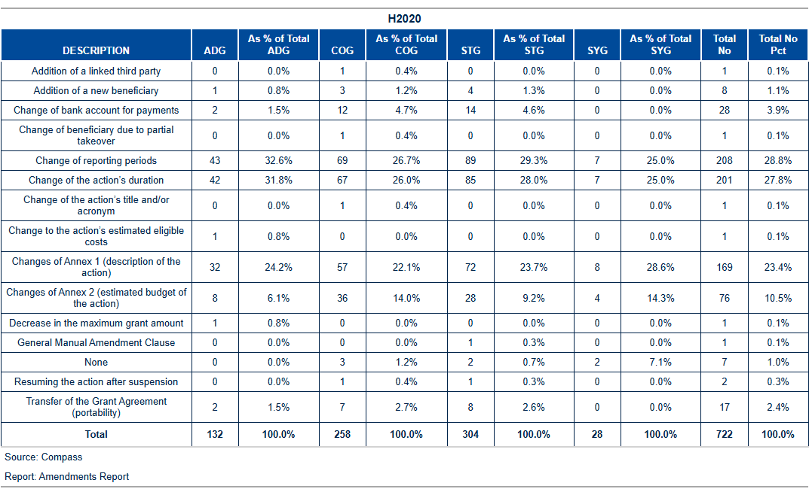

Table 10b: H2020: Reasons for amendment.

H2020 Amendments performance: Time to Amend

The current_year average time to amend is amd_TTA_H2020 days, which is below the foreseen contractual time limit of 45 days. With amd_not_ontime delayed amendments signed during the month, the yearly percentage of amendments on time is pct_amd_ontime %.

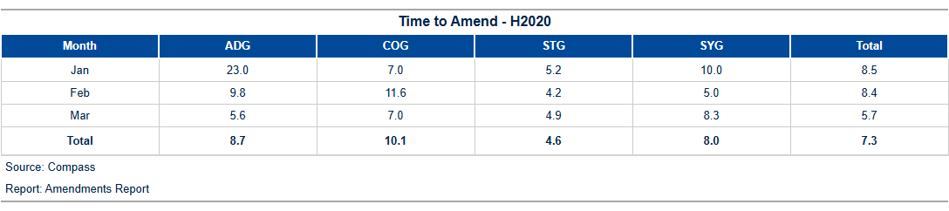

Table 10c: H2020 Time to amend.

The figure below shows the monthly evolution of the time to amend for requests initiated by beneficiaries:

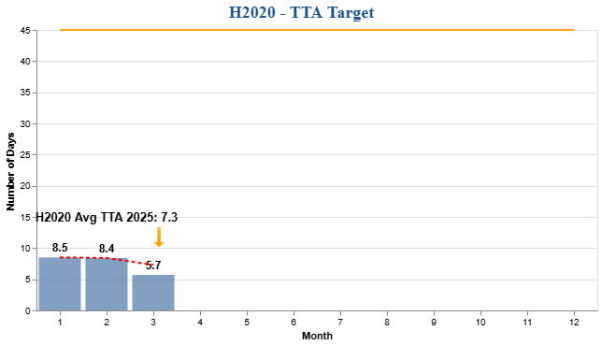

Figure 6a: H2020 Time to Amend – Monthly Evolution

HEU – Amendments activity

In quarter_period , amd_received_HEU new requests for amendments were received from beneficiaries, while amd_signed_HEU of these requests were signed. The table below offers an overview of the total number of amendment requests initiated by beneficiaries, formally received, and processed since the beginning of current_year :

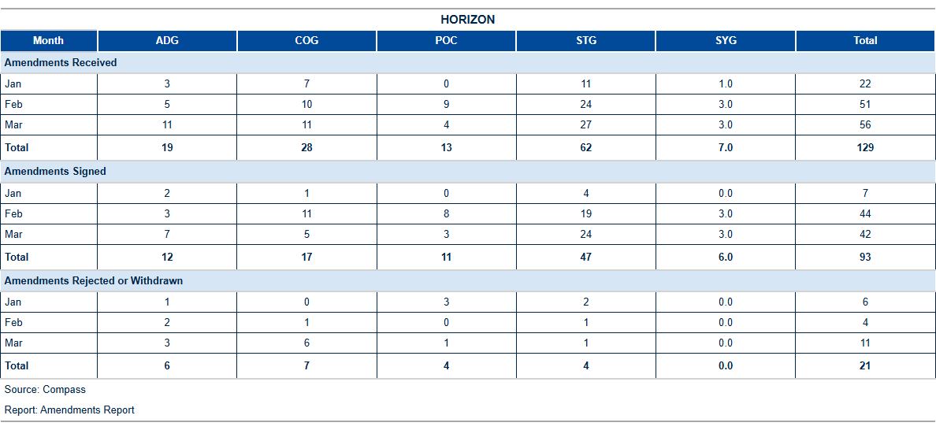

Table 10d: HEU Amendments activity[4]

The table below shows the reasons for amendments open or signed in , and initiated by the beneficiary (one amendment request may include more than one reason):

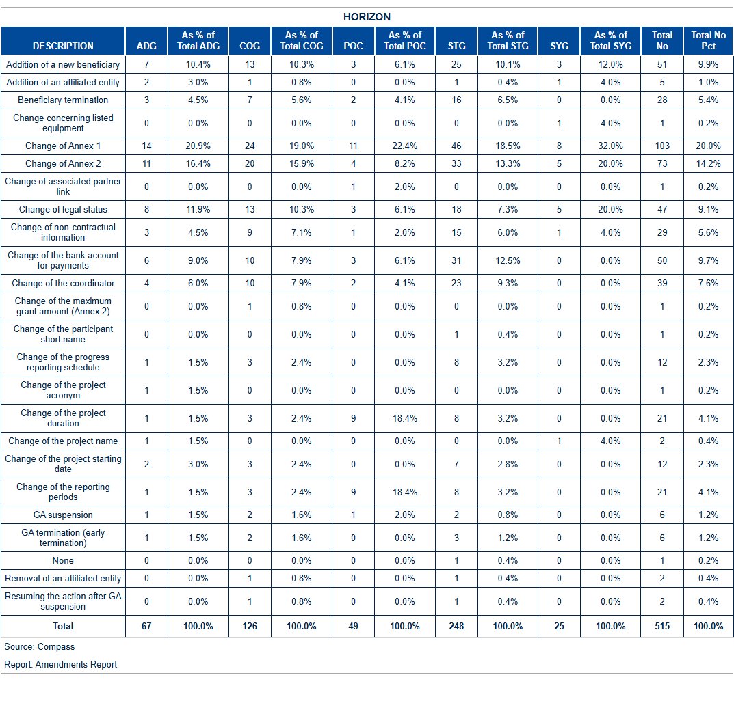

Table 10e: HEU: Reasons for amendment.

HEU Amendments performance: Time to Amend

The current_year average time to amend is amd_TTA_HEU days, which is below the foreseen contractual time limit of 45 days. With amd_not_ontime_HEU delayed amendments signed during the month, the yearly percentage of amendments on time is pct_amd_ontime_HEU %.

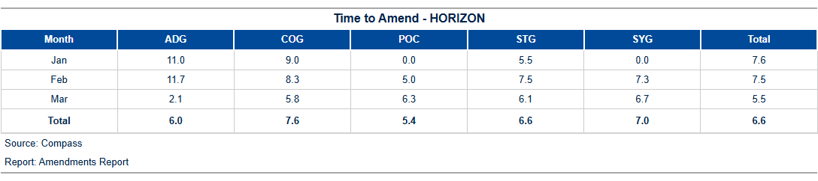

Table 10f: HEU Time to amend.

The figure below shows the monthly evolution of the time to amend for requests initiated by beneficiaries:

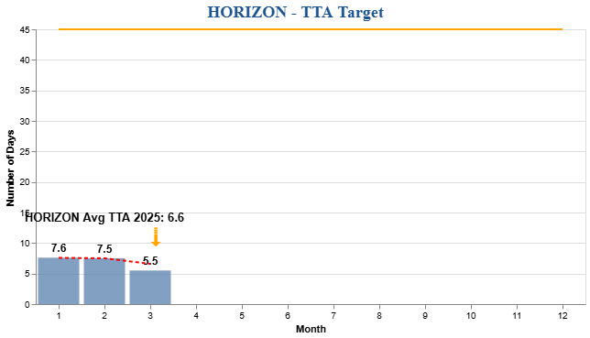

Figure 6b: H2020 Time to Amend – Monthly Evolution

1. H2020 External Audit Follow-Up – Grants

Planning and implementation of external audits

According to H2020 financial guidelines, the CIC may carry out financial audits on ERCEA projects at any time during the implementation of a project and up to five years after the end of a project.

The below shows the status of the **foreseen audits** in current_year according to the annual work programme (AWP 2024) compared to the planned/ongoing and closed ones. An audit is **planned** (or identified) when the contract with the external auditor (framework contractor) is signed or in the case of own resources, the in-house auditing team is assigned. As soon as the beneficiary receives the **announcement** **letter** (that an audit will take place at his premises) the audit is launched and considered **ongoing**.[5] By sending the **letter of conclusion** to the beneficiary the audit is **closed**.

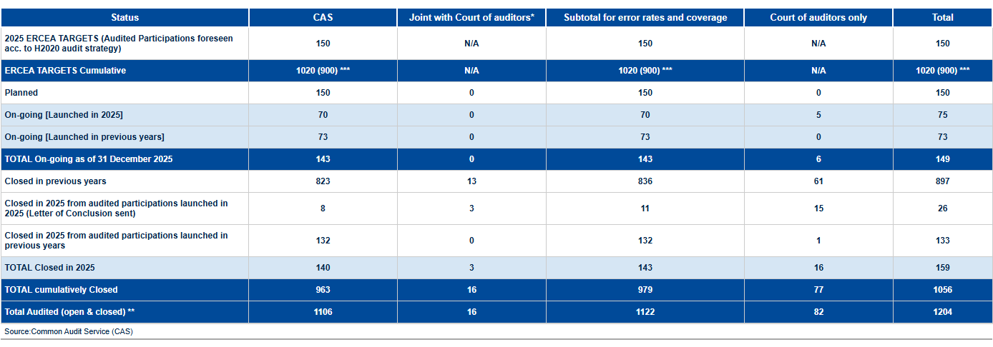

ERCEA audit programme 2024: State of play

*One audit may consist of several projects being audited at the premises of one Host Institution.*

The table below gives an overview of the error rates:

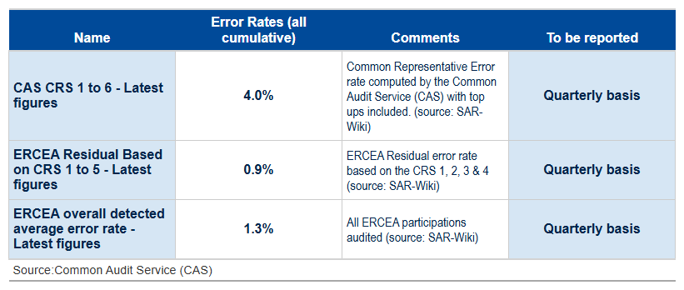

Table 11b: Error rates

The table below shows the cumulative activities on the implementation of external audits from the moment the final audit report has been sent to the beneficiary and the amount to be recovered/paid has been established (by project).

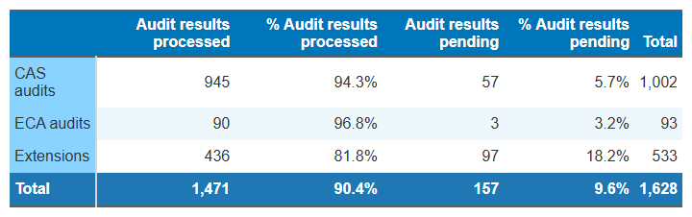

Table 11c: H2020 Implementation of the audit results (status of all ERCEA H2020 AURIs).

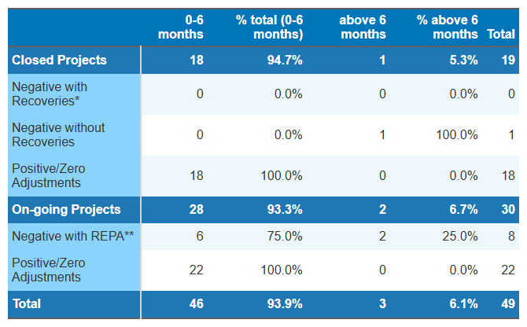

Table 11d: H2020 Implementation of the audit results (Annual Time to Implement – AURIs closed in 2024)

*On-going and closed projects with positive or zero adjustment and closed projects with negative adjustments not triggering a recovery order AURIs are finalized within 6 months*

*\* Target for closed projects with negative adjustments triggering a recovery order: at least 50% of AURI are finalized within 6 months;*

*\*\* Time to implement negative adjustments in ongoing projects = between launch of AURI workflow up to completion of Authorisation step.*

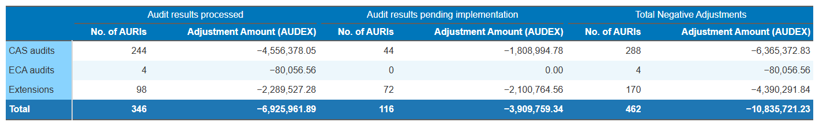

Table 11e: H2020 Implementation of the audit results (Implementation of negative adjustments – AUDEX Amounts)

*Deviations due to rounding differences (+/- 1 EUR) are excluded.*

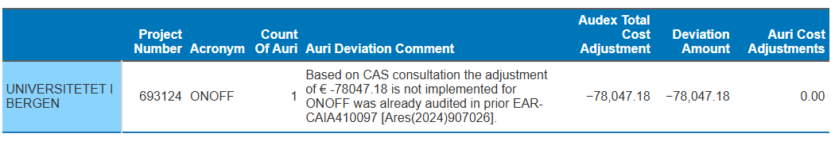

Table 11f: Deviations in implementation of negative adjustments

H2020 & HEU – Issued and cashed recovery orders

The table shows an overview of all issued, cashed/offset, and open H2020 recovery orders since the beginning of the year. Further details on the origin of the recovery orders are given in the below table.

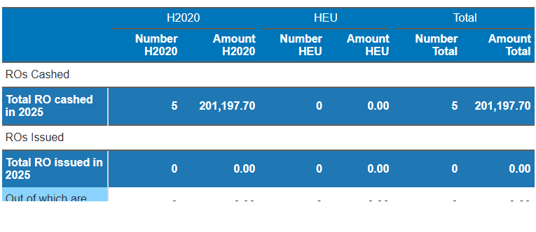

Table 12a: H2020 & HEU – recovery activity in 2025.



1. Reinforced Monitoring

This table serves as a reminder to remove the reinforced monitoring flag from projects that have exceeded their monitoring due dates. It categorizes projects according to their proximity to the due date, with a focus on highlighting those with expired flags to prompt immediate action.

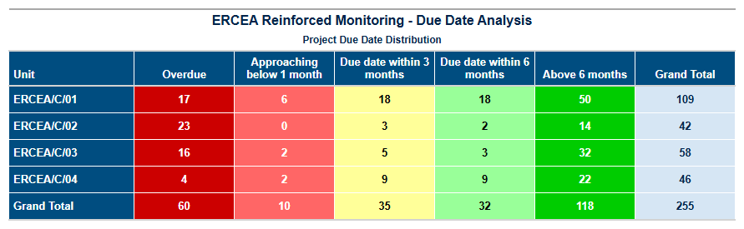

Table 13: HEU- recovery activity in 2025.

1. Guarantee Fund

H2020



Contributions to the Guarantee Fund

Nothing has been transferred to the Guarantee Fund since late 2022.

Reimbursements to Participants

Since the beginning of 2025, an amount of € 19,043,209.01 has been reimbursed from the Guarantee Fund to the participants.

Return to Budget Line

Since the beginning of 2025, an amount of € 1,413,628.89 has been returned to the budget line.

Interventions from the Guarantee Fund

None.

HEU

Contributionsions to the Guarantee Fund

Since the beginning of the 2025, an amount of € 25,465,155.12 has been transferred to the Guarantee Fund.

Figure Figure 7: HEU Contribution to the Guarantee Fund.

Reimbursements to Participants

Since the beginning of 2025, an amount of € 330,000.00 has been reimbursed from the Guarantee Fund to the participants.

Return to Budget Line

Since the beginning of 2025, no funds have been returned to the budget line.

Interventions from the Guarantee Fund

None.

1. Annex 1 – targets and indicators

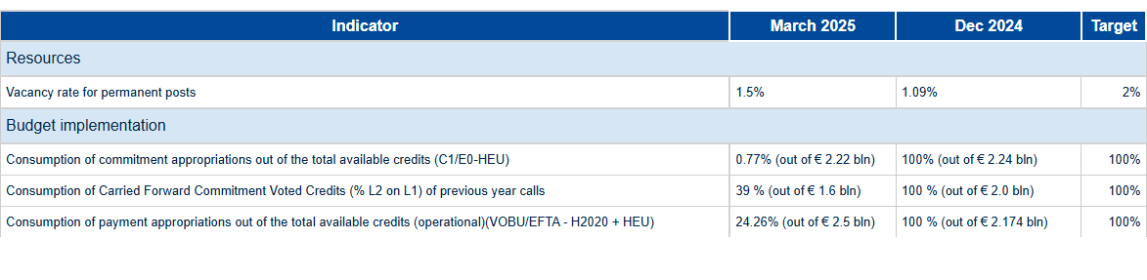

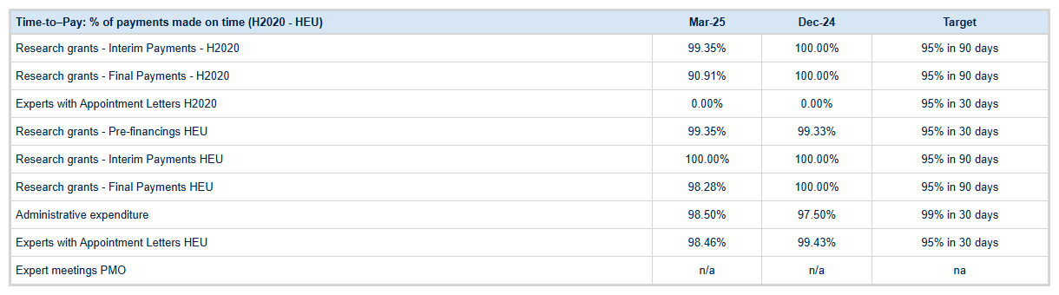

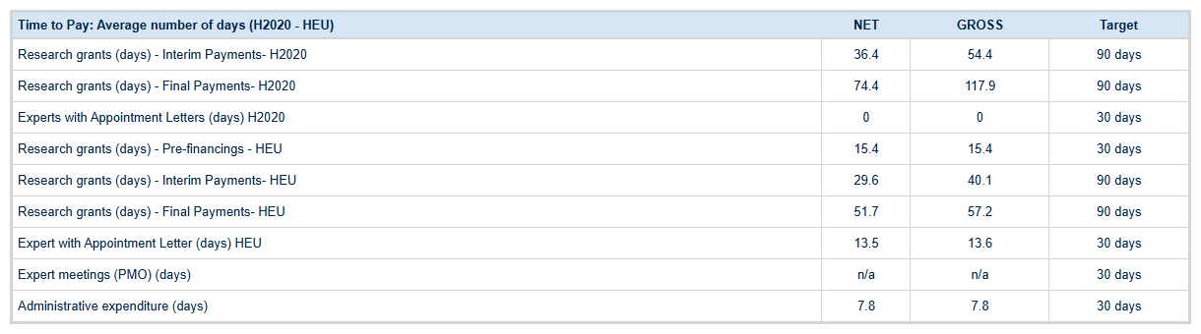

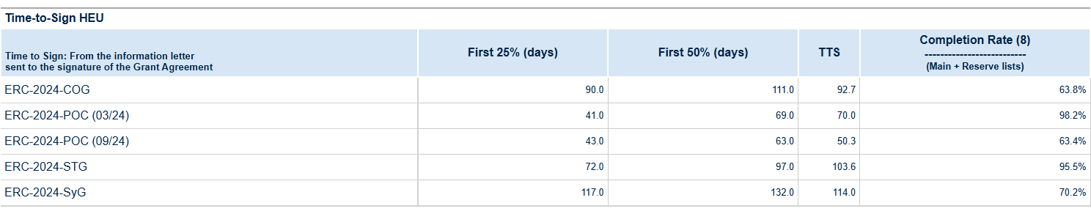

|  |  |  |  |
| --- | --- | --- | --- |
| **Time to Grant (Main and Reserve list)** |  | **Dec-24** | **Target** |
| HEU cumulatively (days) | {{ HEU_TTG_TOTA }} | 334.7 | - |
| HEU Average since 1 January (days) | 338.42 | 356.7 | - |
| **Error rate (Quarterly basis)** |  | **Dec-24** | **Target** |
| **(Last results)** |
| H2020 ERCEA average detected error rate | 1,20% | 1,29% | - |
| H2020 ERCEA residual error, based on applying the Research Family CRS error rate to ERCEA ‘s population | 0.94% | 1,02% | ≤2% |

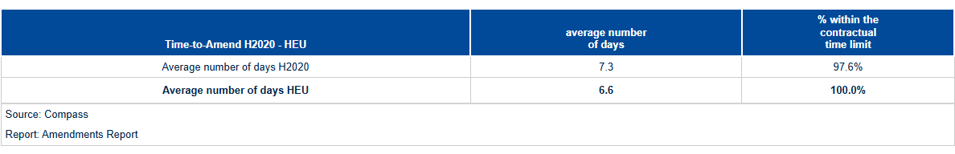

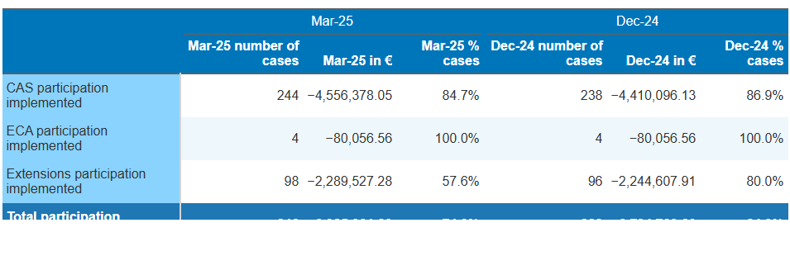

1. Annex 1 – Time to Pay

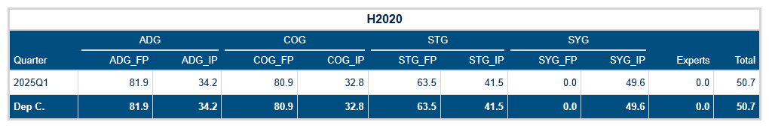

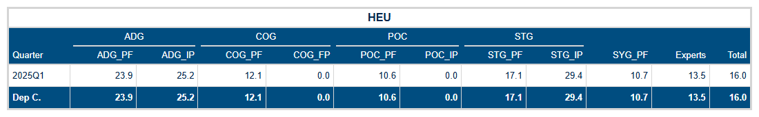

Tables 14a-14b: Time to Pay for the H2020, and HEU programmes.

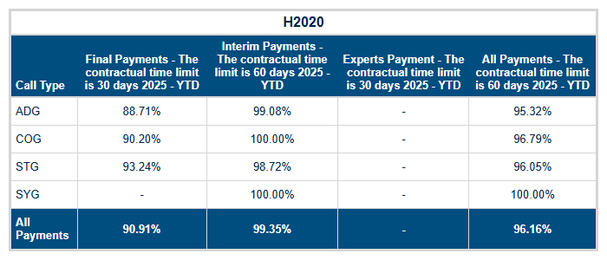

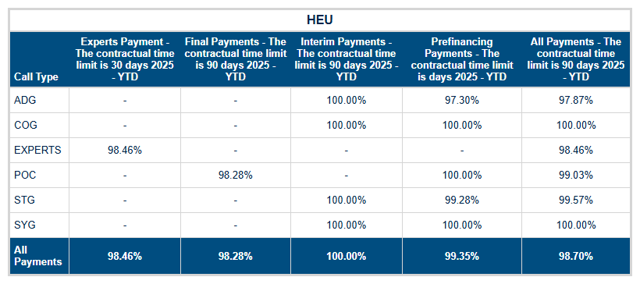

Tables 14dc-14d: Time to Pay – grant and expert payments executed on time.



Contact: Soudaina.WALA@ec.europa.eu

https://erc.europa.eu/



Designed by: Edward Smith | Edward.Smith@ec.europa.eu

Edited by: Luigi Vinciguerra | Luigi.Vinciguerra@ec.europa.eu

Contributions: Daniel Negura - Daniel.Negura@ec.europa.eu | Philippe Callens – Philippe.Callens@ec.eruopa.eu



1. Idem as footnote 5.
2. Source: ABAC Data Warehouse, Business Objects report named "DWH-Time_To_Invoice".
3. Amendments for which a specific request date have been encoded in the database. Amendments received include as well withdrawn, rejected and cancelled ones.
4. Amendments for which a specific request date have been encoded in the database. Amendments received include as well withdrawn, rejected and cancelled ones.
5. Compare the Audit Process Handbook of the European Commission.